Modern Cpp:

- **std::map** is an associative container that stores key-value pairs in a binary search tree (usually a red-black tree).

* Iterators for **std::map** are implemented differently compared to **std::vector** due to the tree-based structure of **std::map**.
* **std::map** iterators are typically implemented as pointers or smart pointers to nodes in the binary search tree.
* Traversal of a **std::map** involves navigating through the tree structure, following the rules of binary search trees (e.g., left child, parent, right child).
* Iterators for **std::map** are bidirectional iterators, allowing forward and backward traversal but not supporting pointer arithmetic like random-access iterators.

**Underlying Container**: By default, **std::stack** is implemented using **std::deque**. However, you can specify a different underlying container type as a template argument if needed.

The inherent data structure for **std::unordered_set** is a hash table.

Internally, **std::unordered_set** is typically implemented as an array of linked lists (or sometimes as a dynamic array of arrays), where each element in the array corresponds to a bucket. When an element is inserted into the **unordered_set**, its hash value is computed and used to determine the bucket it belongs to. The element is then added to the linked list (or array) associated with that bucket.

The unordered_set can contain a key of any type – predefined or user-defined data structure but all the keys must be unique

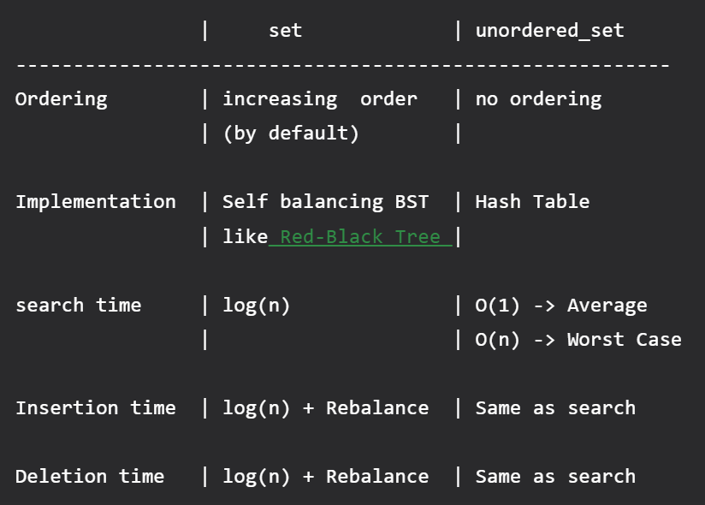

set and map in STL are similar in the sense that they both use [Red Black Tree](https://www.geeksforgeeks.org/red-black-tree-set-1-introduction-2/)(A self balancing [BST](https://www.geeksforgeeks.org/binary-search-tree-set-1-search-and-insertion/)). Note that the time complexities of search, insert and delete are O(Log n).   
**Differences**:   
The difference is [set](https://www.geeksforgeeks.org/set-in-cpp-stl/) is used to store only keys while [map](https://www.geeksforgeeks.org/map-associative-containers-the-c-standard-template-library-stl/) is used to store key value pairs.

Initializer_list :

Initializer lists provide a concise and flexible way to initialize member variables in constructors, as demonstrated in the **MyClass** constructor. They allow constructors to accept multiple values without needing to define a separate constructor for each combination of arguments.

Std::allocator :

**std::allocator** is a standard library class template in C++ that provides a mechanism for allocating and deallocating memory. It serves as the default allocator used by standard containers like **std::vector**, **std::list**, **std::map**, etc., to manage memory allocation for their elements.

The primary purpose of **std::allocator** is to abstract the process of memory allocation and deallocation, allowing containers to work with different memory management strategies without being tightly coupled to specific allocation mechanisms.

Here's a brief overview of how **std::allocator** works:

1. **Allocation**: The **std::allocator** class provides the **allocate()** member function, which is used to allocate memory for a specified number of objects of a given type. It internally calls the **operator new** to allocate memory.
2. **Deallocation**: The **std::allocator** class also provides the **deallocate()** member function, which is used to deallocate memory that was previously allocated with **allocate()**. It internally calls the **operator delete** to deallocate memory.
3. **Construction and Destruction**: In addition to memory allocation and deallocation, **std::allocator** also handles the construction and destruction of objects in the allocated memory. It provides the **construct()** and **destroy()** member functions for this purpose.
4. **Rebinding**: **std::allocator** is parameterized on a single type (**T**). However, it supports rebinding to allocate memory for different types. This is achieved using the **rebind** template alias provided by the allocator.
5. **Custom Allocators**: Programmers can define their custom allocators by providing their own implementations of the allocation, deallocation, construction, and destruction operations. Custom allocators can be used with standard containers by specifying them as template parameters.

Top of Form

functional, callable, std::function :  
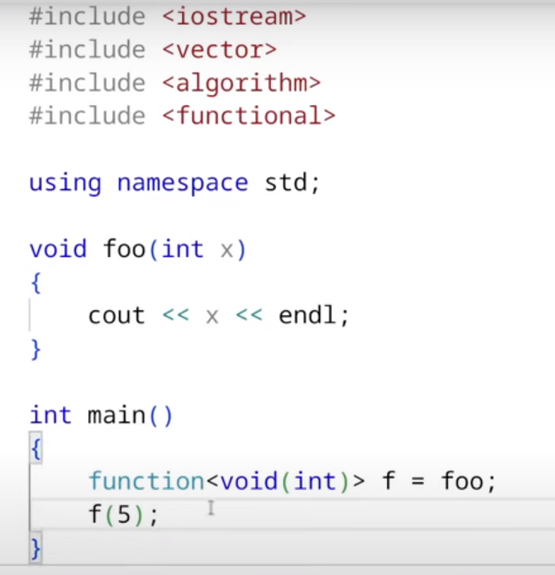

same thing using lambda :  
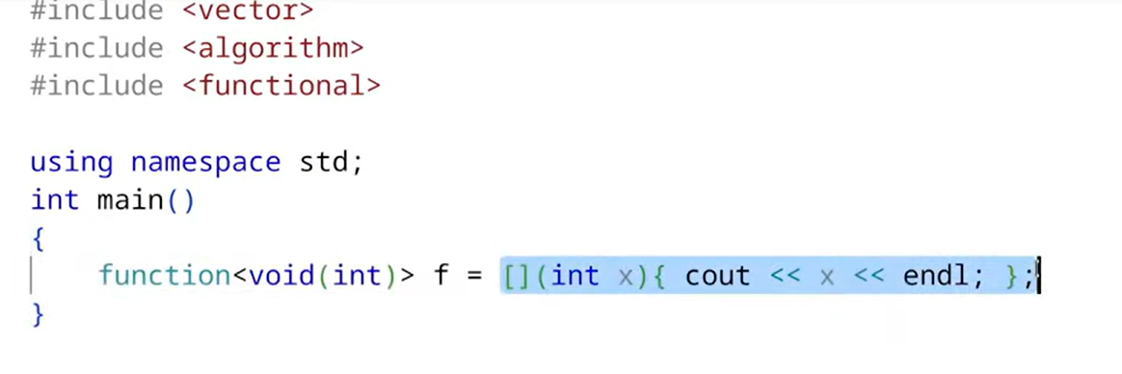

same thing using function pointer :  
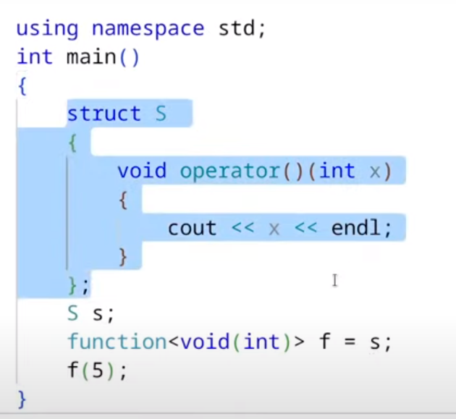

exercise : what will be its output?  
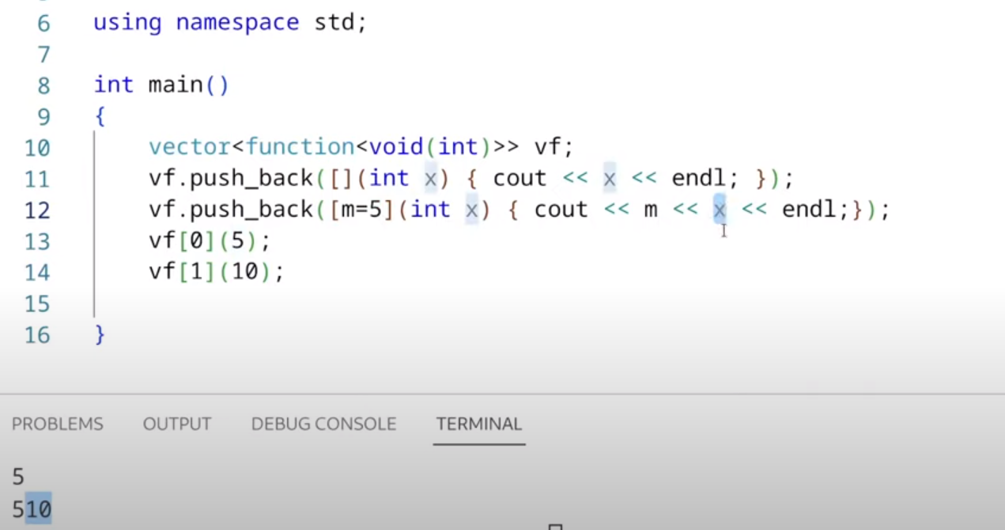

drawback : std::function is slower compared to regular function call.  
**std::function**: **std::function** provides more flexibility than function pointers because it can hold any callable object, including function pointers, lambda functions, and function objects. However, this flexibility comes with some overhead, as **std::function** typically involves dynamic memory allocation and virtual function calls to dispatch the call to the appropriate function object.

* A void pointer can point to any type of variable,
* Int x =10;
* Float *p = &x; //error
* Void *p = &x; //fine
* You cannot read from a nullptr, neither can u assign something to a nullptr.
* Eg: int *p = nullptr;
* Std::cout<<*p; //error- read access violation
* *p =10; //error- write access violation  
  Dereferencing a null pointer leads to undefined behavior, which means the behavior of the program is unpredictable. Sometimes the above statements may compile, but provide UB at runtime.
* Const keyword is replacement for macros, they do not have a scope. The MACROS are not type safe, they may lead to bugs which are difficult to debug.
* Assigning const value to a ptr is not allowed, e.g. :

Const int chunkSize = 10;

Int *ptr = &chunkSize; //not allowed as it may lead to following line

*ptr =5;

- However, this is allowed :  
const int *ptr = &chunkSize;

- “auto” keyword does not work with qualifiers like,  
static auto x = “dvcgf”;

Example : const int x =5;

Auto var = x; // here var is not const by default, you need to apply qualifier “const” with it to make it const.

* However, if we use auto with a reference, the qualifier is not discarded.
* Auto &var = 5; // const retained.
* Auto list {1,2,3,4,5}; // not work
* Auto list = {1,2,3,4,5}; //works

When using the **auto** keyword in C++, qualifiers like **\***, **const**, **&**, and **static** can affect the type deduction process. Here's how you can use them:

1. Pointer Qualifier **\***:
   * When the initializer is a pointer, **auto** will deduce the type as the pointed-to type.

int x = 10;

auto* ptr = &x; // Type of ptr is int*

1. **const** Qualifier:

* **const** qualifiers are **NOT** preserved during type deduction.

const int y = 20;

auto a = y; // Type of a is const int

auto& b = y; // Type of b is const int&

1. Reference Qualifier **&**:

* When the initializer is a reference, **auto** will deduce the type as the referenced type.

int z = 30;  
auto& ref = z; // Type of ref is int&

1. **static** Qualifier:

* **static** qualifiers are not preserved during type deduction. They are ignored.

static int value = 42;

auto c = value; // Type of c is int

**C++ concurrency :**

* If we call a function which takes certain processing time, the main thread waits for it to finish, then it returns back.
* Sometimes, the application freezes for a long time waiting for the main thread to finish its job, and this creates a bad user experience. That’s why if we have a long running operation in our application, they should be kept in a separate thread.
* Solution : std::thread
* Accepts a callable as a constructor argument.
* The callable is executed in a separate thread.
* The constructor does not wait for the thread to start, it immediately returns to the calling function.
* Resides in <thread> header.
* Applying thread basics :
* Std::thread th(download); // void download() is a function.
* th.join(); // this is essential , if this is not applied the main thread will execute and finish, it will not wait for the child thread to finish. So we need to call join somewhere before the main thread object is destroyed, preferably at the end because the join() method blocks the main thread from running.
* In some cases, we may have a long running thread and we don’t want main to wait for that thread, so we can use “detach” in that case. Note that a detached thread cannot be joined, To check whether a thread can be joined or not, you can call joinable() on it.
* If th.joinable() {

th.join();

}

* If we put system call of pause, we can see the thread start.
* Please note that a joinable thread can be made detached later, but if a thread is detached, it can never be made joinable again. A detached thread will automatically release its resources when the thread object is destroyed.

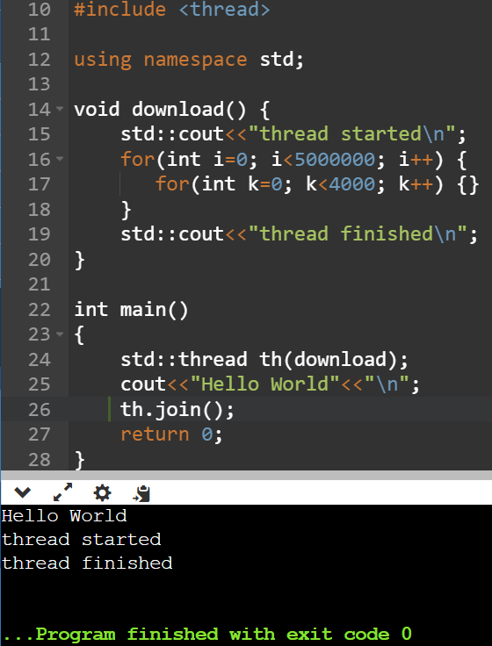

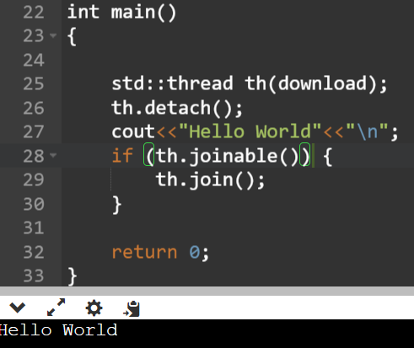

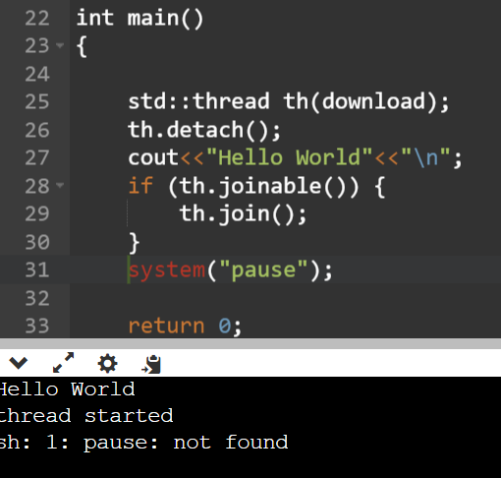

How to pass arguments to thread function, the constructor of a thread function is a variadic one, which means it can accept any number of arguments.

The first value in this constructor is always the callable and then u can pass the arguments to that callable in the consecutive arguments.

* If we want to pass a reference to a function that is called inside a thread, we’ll have to use std::ref(name), instead of &name;
* If we want to pass a const reference, we’ll have to use std::c_ref(&name)

For example, :

Void download(const string &file) {}

Int main{

Std::thread th(download, std::cref(filename));

}

Calling function inside a class in thread  
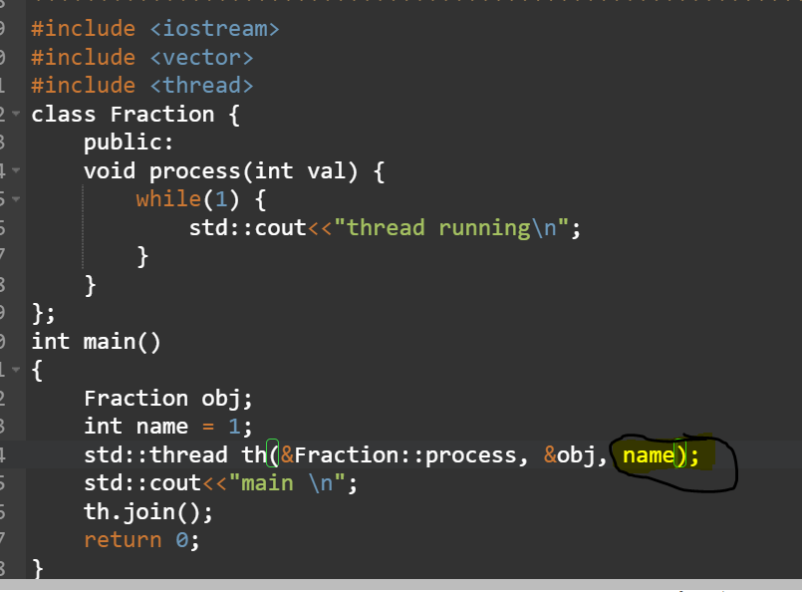

If we want to pass by reference  
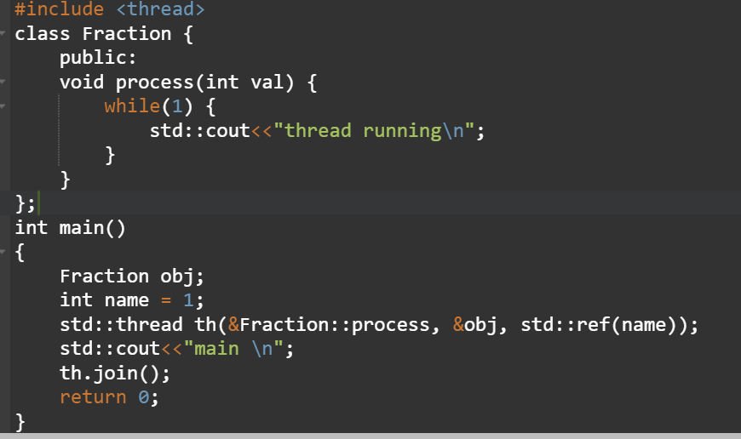

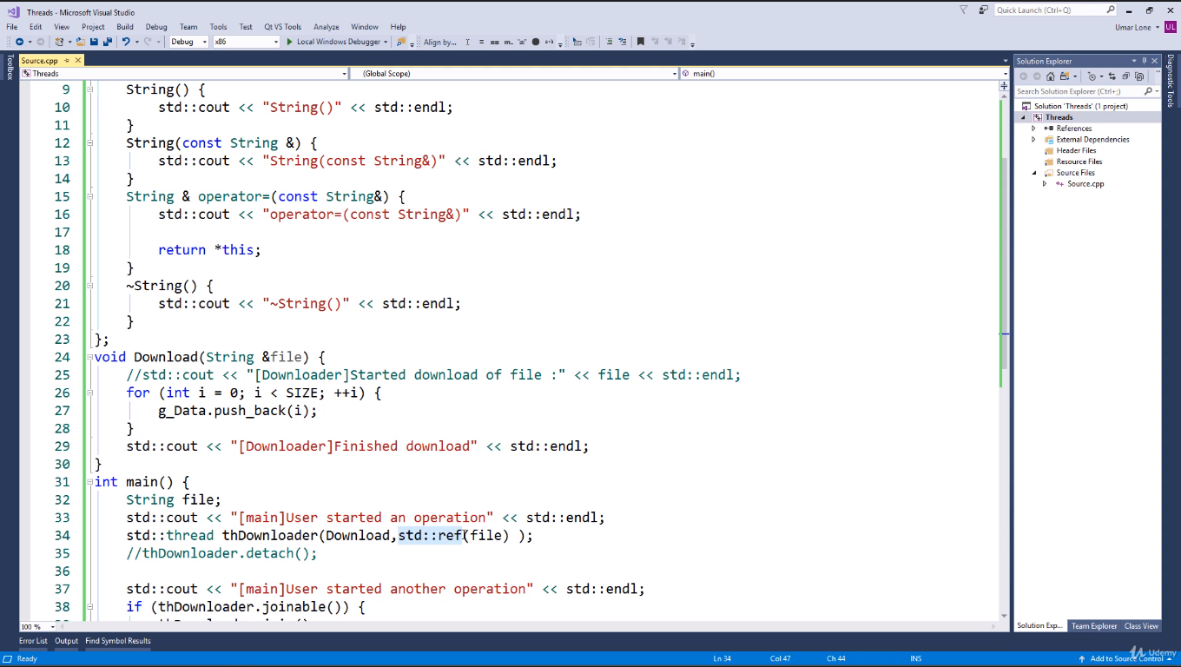

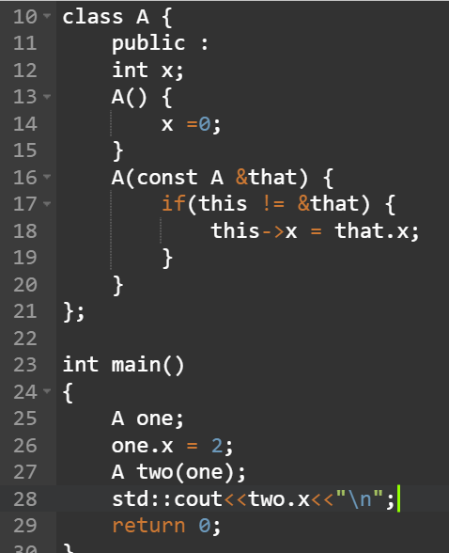**Copy Constructor**: A copy constructor initializes a new object as a copy of an existing object of the same class. It is called when an object is passed by value, returned by value, or initialized with another object of the same class.

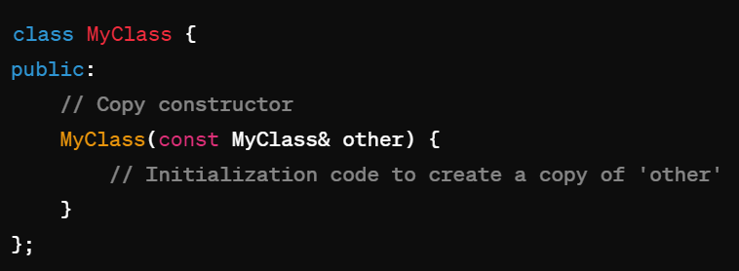

**Move Constructor**: A move constructor initializes a new object by "stealing" resources from an existing object, typically an rvalue. It is used in move semantics to efficiently transfer resources, such as memory or ownership, from one object to another.  
  
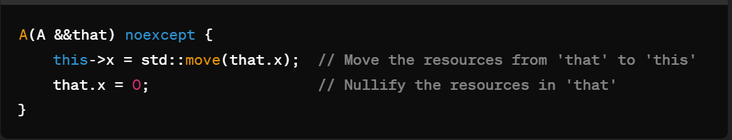

**Copy Assignment Operator (operator=)**: The copy assignment operator is used to copy the state of one object to another object. It is called when an object is assigned the value of another object using the assignment operator (**=**). By default, if not explicitly defined, the compiler provides a copy assignment operator that performs a shallow copy of the object's member variables.

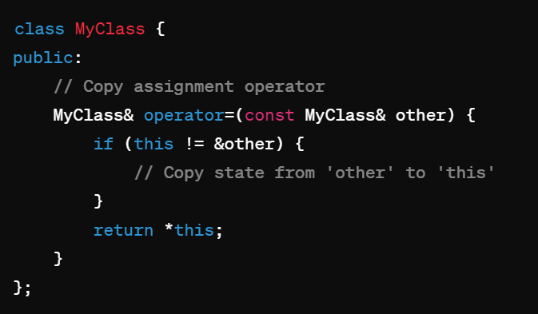

**Move Assignment Operator (operator=)**: The move assignment operator is used to transfer resources from one object to another, typically in move semantics. It is called when an object is assigned the value of an rvalue, such as the result of a function returning by value or an explicitly casted object. Move assignment allows for efficient transfer of resources, avoiding unnecessary copying.

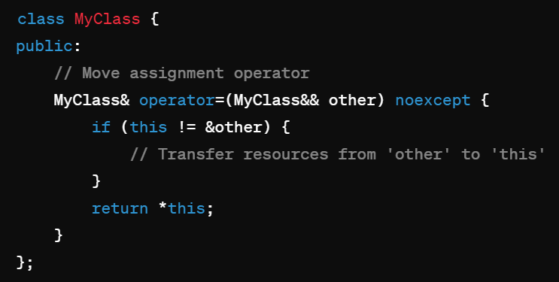

If the copy assignment operator or move assignment operator is not explicitly defined in a class, the compiler provides a default implementation. However, if the class contains member variables that require deep copying or resource management, it's often necessary to define custom copy and move assignment operators to ensure correct behavior.

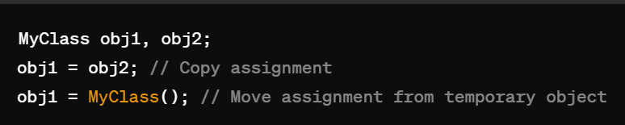

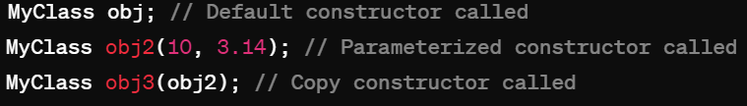

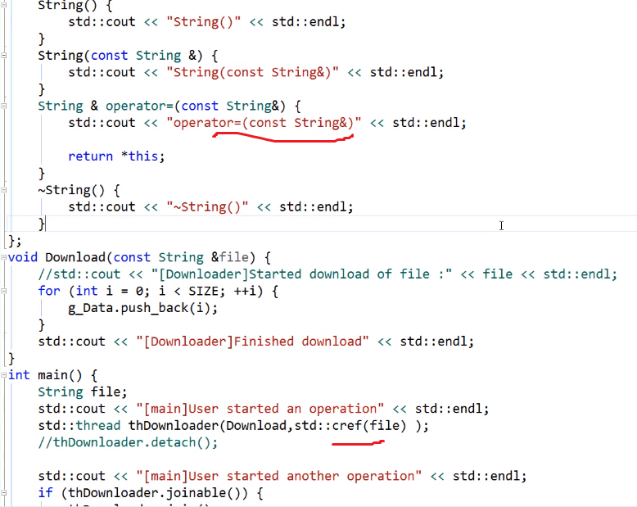

If we don’t do this and directly pass, name expecting it to be treated as reference by thread will not work, it will call 2 constructors in that case, one of which will be copy constructor.

* Returning value from a thread is complicated.

**std::packaged_task** is a class template in C++ that represents a packaged task: a function or callable object that can be asynchronously invoked and whose result (or exception) can be retrieved asynchronously.  
  
A **std::packaged_task** is a class template in C++ that represents a task that can be executed asynchronously. It encapsulates a callable object (such as a function, lambda expression, or functor) and allows it to be invoked asynchronously and get its result in the future.  
Here's a brief overview of how **std::packaged_task** works:

1. You create a **std::packaged_task** object by providing it with a callable object (e.g., a function, lambda, or functor) that takes no arguments and returns a value.
2. You can then obtain a **std::future** object from the **std::packaged_task**. This future represents the result of the computation that will be produced when the task is executed.
3. You can execute the task asynchronously using a **std::thread**, **std::async**, or any other mechanism for asynchronous execution.
4. Once the task is executed, the result (if any) will be stored in the associated **std::future** object.

**std::packaged_task** is useful in scenarios where you need to perform some computation asynchronously and obtain the result later. It provides a convenient way to decouple the computation from its execution, allowing you to execute it in parallel with other tasks.

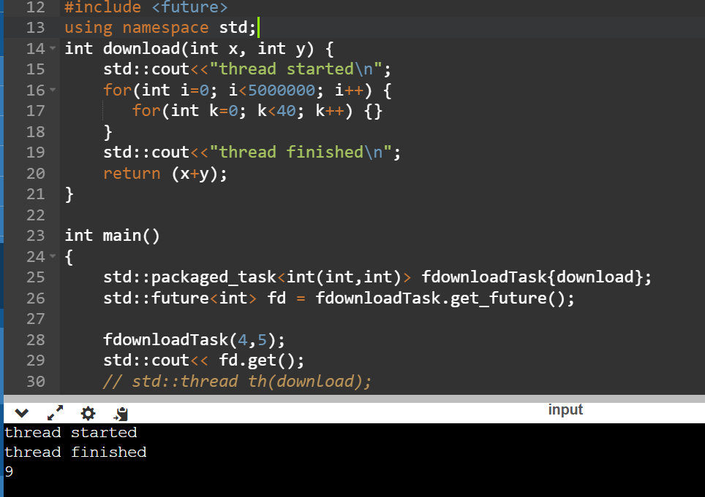

The packaged_task class does not allow copies, that’s why we have to use std::move with it. (see eg below)

Now to use it with thread,

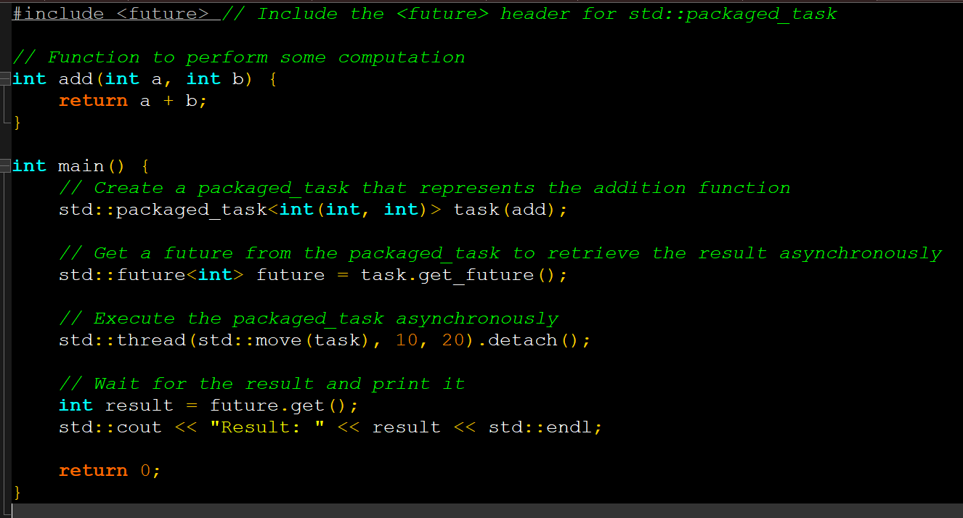-Another way of making data return from thread is by making that data global, so that everyone can access it once it has been modified by the thread.

However, when 2 threads access the same data, a race condition occurs in which one thread alters the data before the state of that data was properly changed by another thread.

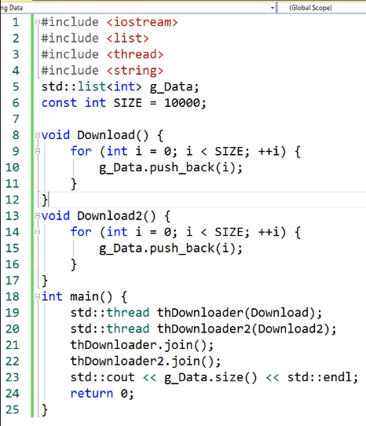

That is why, we need a mutex or lock on the data.

* A mutex is an object which allows threads to lock it, but at a time only one thread can lock it. If other threads try to lock the mutex, they will be put in a wait queue.
* So we can use mutex, to synchronize the access to this data.

A proper way of using Mutex ,

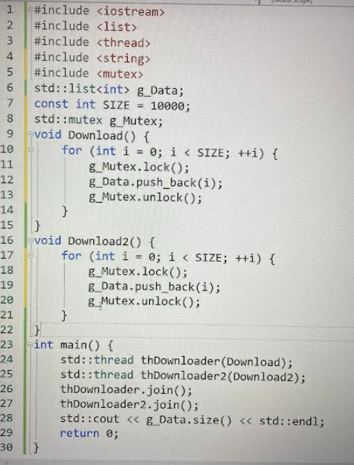

However , if one of the threads terminates before unlocking the mutex, the program never terminates, this is a deadlock condition like shown below :

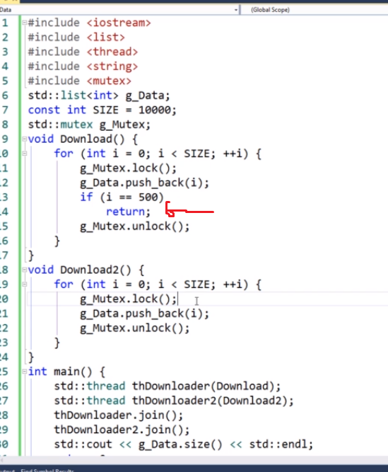

So to avoid this deadlock condition we use lock_guard, which implements RAII .

Implementation :

We have a global variable called , std::mutex g_mutex;

Then inside thread function we have

Void download () {

Std::lock_guard<std::mutex> mtx (g_mutex);

}

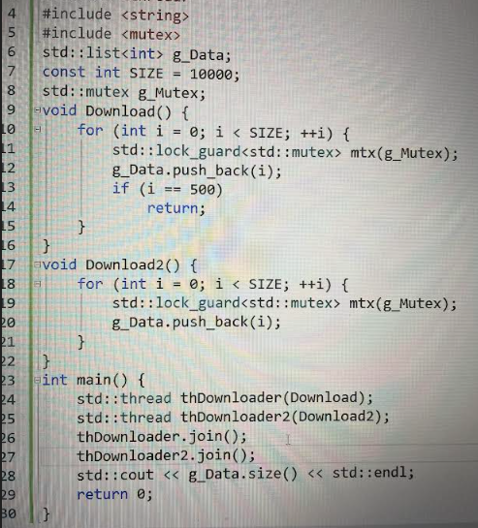

But when thread is accessing the resource, the other thread is sitting idle, even though the CPU is free. This is a wastage of CPU time as a resource, therefore in general, mutex should be avoided.

RAII : resource acquisition is initialization. We use the constructor to lock the mutex and destructor to release the mutex.

RAII (Resource Acquisition Is Initialization) is a fundamental principle in C++ programming for managing resource allocation and deallocation in a deterministic and exception-safe manner. The key idea behind RAII is to tie the lifetime of a resource (such as memory, file handles, locks, or other scarce resources) to the lifetime of an object.

The RAII principle is based on the concept of constructors and destructors in C++. Resources are acquired (allocated) during object construction and released (deallocated) during object destruction. This ensures that resources are properly managed and cleaned up when the object goes out of scope, regardless of whether the scope is exited normally or due to an exception.

RAII is implemented using objects that encapsulate the resource management logic within their constructors and destructors. When an object is created, its constructor acquires the necessary resources, and when the object is destroyed, its destructor releases the resources. By using RAII, resource management becomes automatic, deterministic, and exception-safe.

The actual acquisition of a resource in the constructor of a class depends on the type of resource being managed. In C++, resources can include memory allocated with **new**, file handles obtained from opening files, network connections, mutexes, and other types of system resources.

**File Opening**: If the resource is a file, you would open the file using functions like **std::ifstream** or **fopen** in the constructor. For example:

ResourceManager(const std::string& filename) {

// Open the file for reading

file = std::ifstream(filename);

}

**File Closing**: If a file was opened, it should be closed in the destructor:

~ResourceManager() {

file.close();

}

**Locking Mutexes**: If the resource is a mutex or lock, you would acquire the lock in the constructor. For example:

ResourceManager(std::mutex& mutex) {

// Lock the mutex

mutex.lock();

}

~ResourceManager() {

mutex.unlock();

}

**Network Connections**: If the resource is a network connection, you would establish the connection in the constructor. For example:

ResourceManager(const std::string& hostname, int port) {

// Establish a network connection

socket = createSocket(hostname, port);

}

~ResourceManager() {

closeSocket(socket);

}

-To get thread ID there’s a function called get_id.

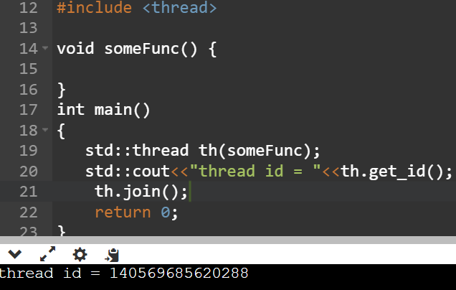

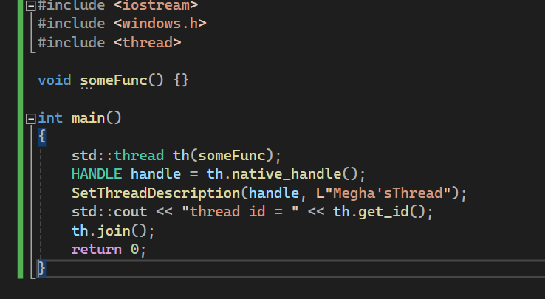

For linux system, instead of SetThreadDescrition, there is a function called P_THREAD_SET_NAME, something like this.

* Std::thread::hardware_concurrency() returns number of cores present in the CPU.

In the context of CPUs (Central Processing Units), "cores" refer to the individual processing units within the CPU chip itself. Each core is capable of executing instructions independently, allowing for parallel processing of tasks.

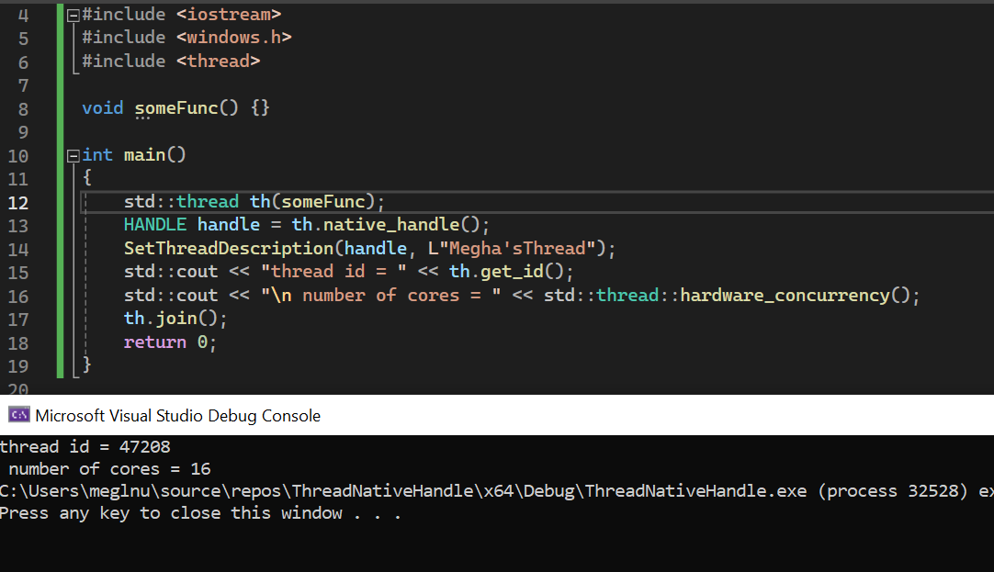

Ideally, the number of threads that should be constructed should be equal to the number of cores for maximum performance.

* Std::this_thread::get_id(); // returns the id of the current running thread, that has called this function.

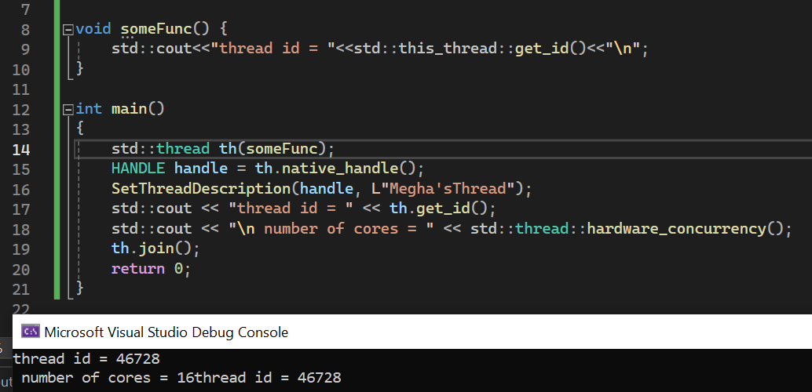

**CPU Core**:

* A CPU core is a single processing unit within the CPU that can independently execute instructions.
* Modern CPUs often contain multiple cores, allowing them to perform multiple tasks simultaneously through parallel processing.
* Each core typically has its own set of execution units, cache memory, and control logic, enabling it to execute instructions independently of other cores.

**Logical Processor**:

* A logical processor, also known as a hardware thread or execution thread, represents a single stream of instructions that can be executed by a CPU core.
* In multi-threaded CPUs, each core may support multiple logical processors, allowing it to execute multiple threads simultaneously through hardware-based multithreading.
* Logical processors share resources within the core, such as execution units and cache, but can independently execute instructions and maintain separate architectural states.



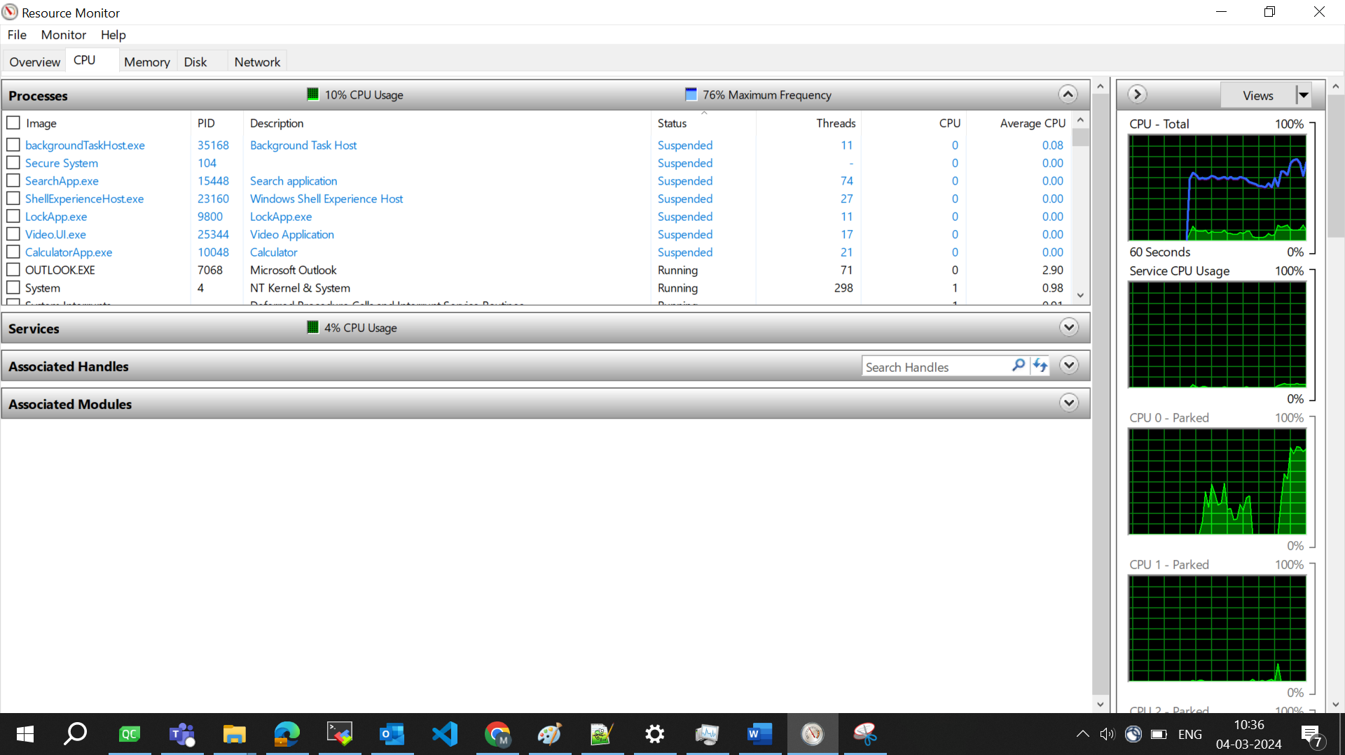

* Std::this_thread::sleep_for(std::chrono::seconds(1));
* Or std::this_thread::sleep_for(1s); // same as above
* Literal like these s and L that were used earlier were added in C++14.

Condition variables in C++ are synchronization primitives used to coordinate the execution of threads. They allow threads to wait until a certain condition is satisfied before proceeding. Here's a basic example of using condition variables:

Producer consumer problem in C++ using condition variables, very important!!  
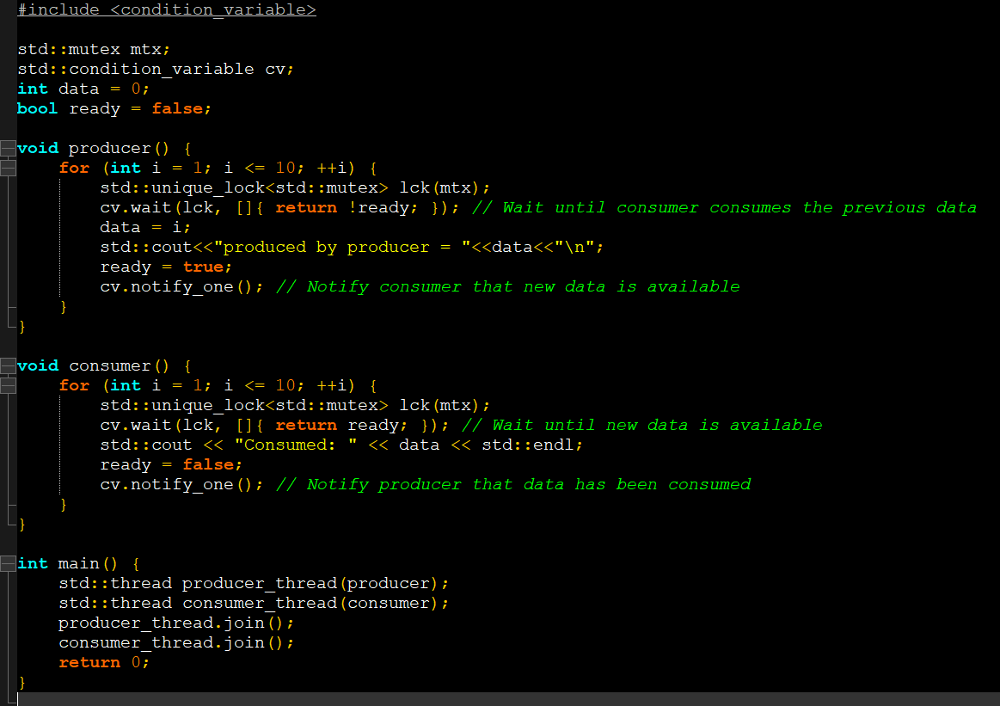

So this was all about low level concurrency which is achieved through thread control.

High level concurrency is more common which is achieved by controlling tasks.

* A task is a function that is automatically created in a separate thread, you don’t need to create the thread yourself. For this, you need to use std::async , which is included in <future>
* Std::async returns a future object that provides access to the result of the callable.

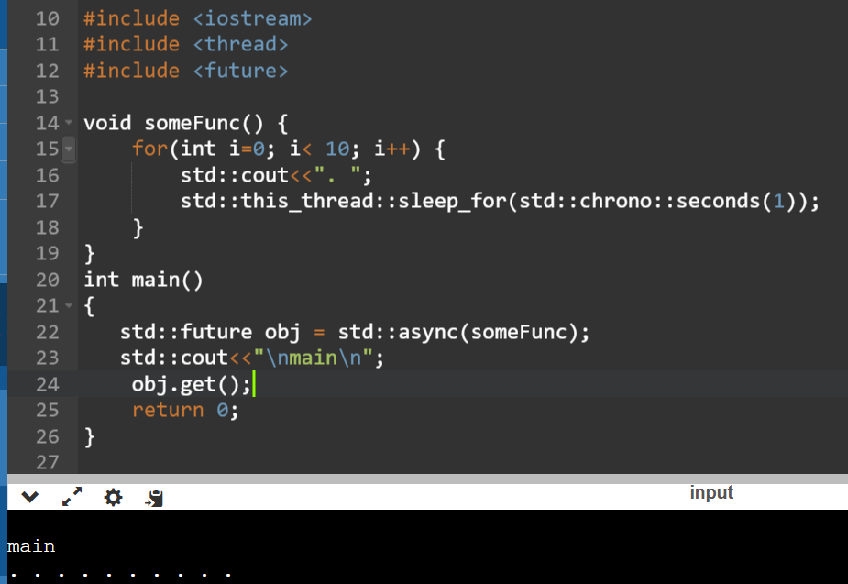

* Launch policies : whether you want to launch thread synchronously, or asynchronously.
* Deferred means : synchronously and asynch , is as name suggest

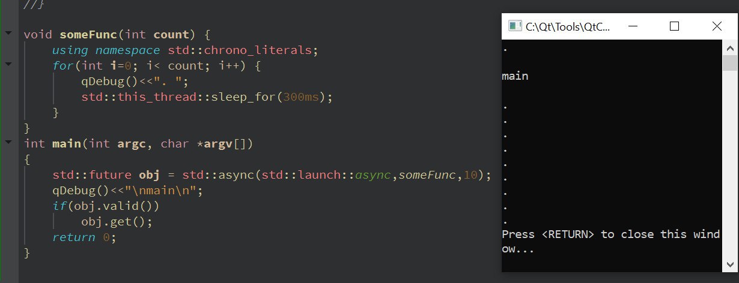

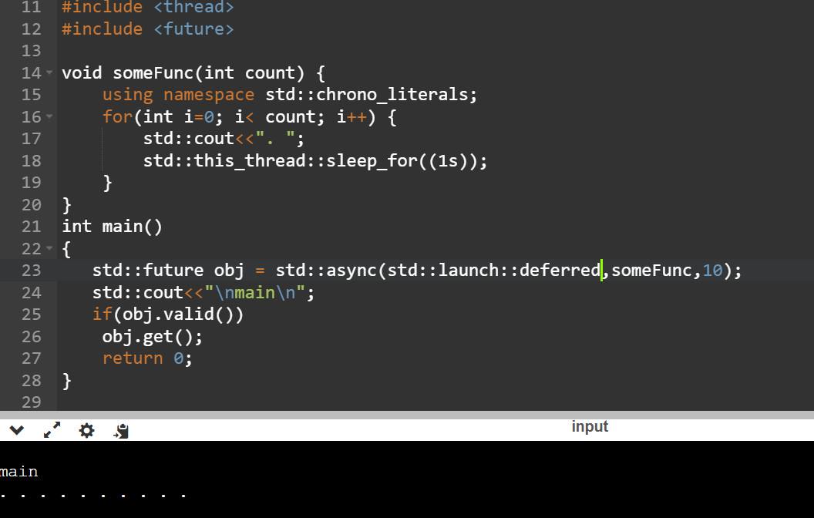

synchronous tasks execute sequentially and block the program's execution until completion, while asynchronous tasks execute concurrently and allow the program to continue executing other tasks while waiting for certain operations to complete. Asynchronous programming is often used in scenarios where responsiveness and scalability are important, such as web servers, user interfaces, and distributed systems.

1. Synchronous Tasks:
   * Synchronous tasks are executed sequentially, one after the other, in a blocking manner.
   * When a synchronous task is initiated, the program waits for it to complete before moving on to the next task.
   * In synchronous operations, the program's execution is halted until the current task finishes executing.
   * Synchronous tasks are typically easier to reason about and debug since the flow of execution is linear and predictable.
2. Asynchronous Tasks:
   * Asynchronous tasks are executed concurrently, allowing multiple tasks to run simultaneously or overlap in time.
   * When an asynchronous task is initiated, the program does not wait for it to complete but continues with other tasks.
   * Asynchronous operations enable non-blocking behavior, meaning the program can continue executing other tasks while waiting for certain operations to complete.
   * Asynchronous tasks are commonly used in scenarios where waiting for I/O operations (such as file I/O, network requests, or database queries) would otherwise cause significant delays in program execution.

Std::promise :

* Provides a way to store a value or an exception.
* This is called the shared state.
* This state can be accessed later from another thread through a future object.
* Promise/future are two endpoints of a communication channel.
* One operation stores a value in a promise and the other operation will retrieve it through a future synchronously.
* These operations are synchronized, therefore thread safe.
* Promise object can be used only once.

Using promise/future, you can share data between two threads, in a thread safe manner without using synchronization.

Promise prepares the shared state to be communicated to another thread in one thread,  
As soon as the shared state is available, it is communicated to another thread via ready state of future.

Once the other thread reads the future through get(), it can never again access the shared state.

As the shared state is destroyed and the future becomes invalid.

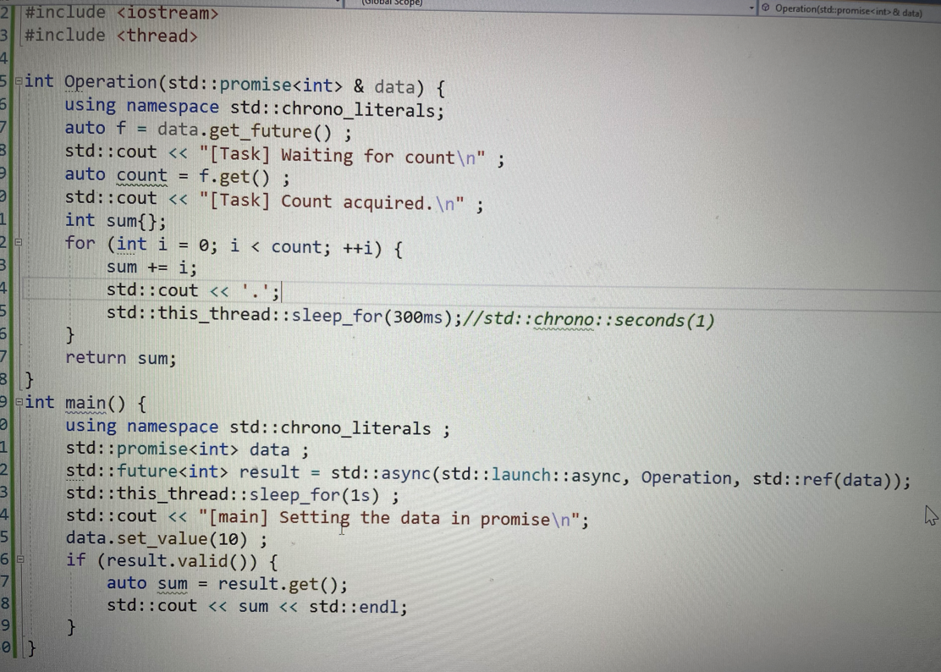

1. how do std::future and std::promise work internally as their execution is independent of the current instruction pointer?  
   They work together to allow one part of a program to produce a result asynchronously and another part to consume that result once it's available.  
     
   **std::promise**: It provides a mechanism for setting a value or an exception that can be retrieved asynchronously using a **std::future** object. Internally, a **std::promise** object contains a shared state that holds the result or exception. When you set a value or exception on the **std::promise** using **set_value()** or **set_exception()**, it updates the shared state accordingly.  
     
   **std::future**: It represents a handle to the result of an asynchronous operation. Internally, a **std::future** object is associated with the shared state of a **std::promise**. When you obtain a **std::future** from a **std::promise**, it allows you to wait for the result or exception to become available. You can use **std::future::get()** to retrieve the result synchronously, or you can use other mechanisms like **std::async** or **std::packaged_task** to retrieve it asynchronously.

The key to understanding how **std::future** and **std::promise** work internally lies in their shared state. When you create a **std::promise** object and obtain a **std::future** from it, both objects share the same state. This shared state is updated when you set a value or exception on the **std::promise**, and it becomes available for retrieval through the associated **std::future**.

Under the hood, **std::future** and **std::promise** use synchronization primitives such as mutexes and condition variables to ensure thread safety and to coordinate access to the shared state. When a thread waits for the result using **std::future::get()**, it may block until the result is available, but other threads can continue to make progress independently. This allows for efficient utilization of resources and parallelism in concurrent programs.

Data.get_future() is different from data.get();

To set a value of promise, call data.set_value(val);

As soon as the value is set on one thread, it is available in another thread for execution.

Data is sent by promise, received in the same thread through future object, if it is valid.

What is the impact of calling get_future() on promise object? And how is calling get() on future object different from calling get() on promise object ???

Thread exceptions waala lecture : didn’t get , need to refer other sources for the same.

* **get_future()** on a **std::promise** returns a **std::future** associated with the promise's shared state, allowing asynchronous access to the result.
* **get()** on a **std::future** retrieves the result or exception from the associated shared state, blocking until the result is available.
* Calling **get()** on a **std::promise** is not valid, as it is used for setting the result, not retrieving it.

Calling **get_future()** on a **std::promise** object returns a **std::future** object that is associated with the shared state of the promise. This allows you to obtain a handle to the result or exception that will eventually be set on the promise. The **std::future** obtained from **get_future()** provides read-only access to the shared state and allows you to wait for the result asynchronously.

Calling **get()** on a **std::future** object retrieves the result or exception from the shared state associated with the future. This operation can block if the result is not yet available, and it returns the value or throws the exception that was set on the promise using **set_value()** or **set_exception()**. Importantly, **get()** on a **std::future** is a blocking operation, meaning it will wait until the result is available before returning.

C++17 features :

ATTRIBUTES :

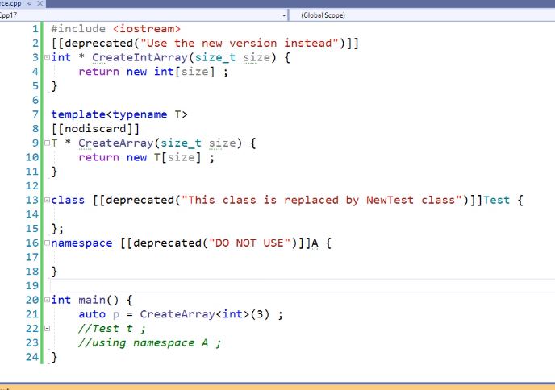

deprecated keyword :   
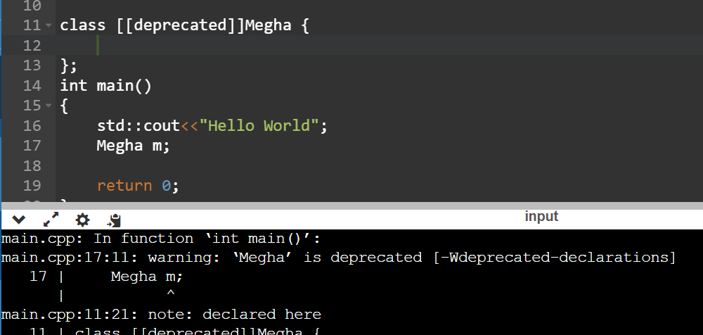

deprecated with message :  
  
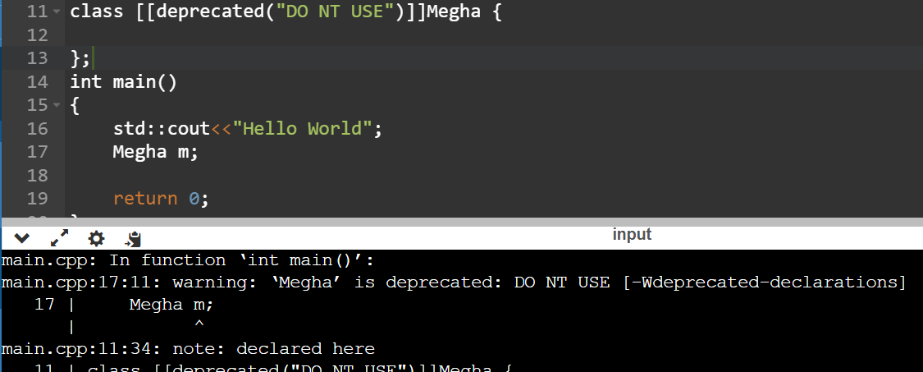

[[nodiscard]] is used because sometimes when the return value from a function is not stored anywhere, it leads to memory wastage on the heap. You can apply [[nodiscard]] on a class also , If you want that every function that returns the object of this class, to be not discarded.

__has_include :FEATURE TEST MACRO, They start with double underscore and they are part of C++20 standard. to check whether a particular .h file is part of the current C++ standard library or it part of experimental library, which means it is not fully available to be integrated.

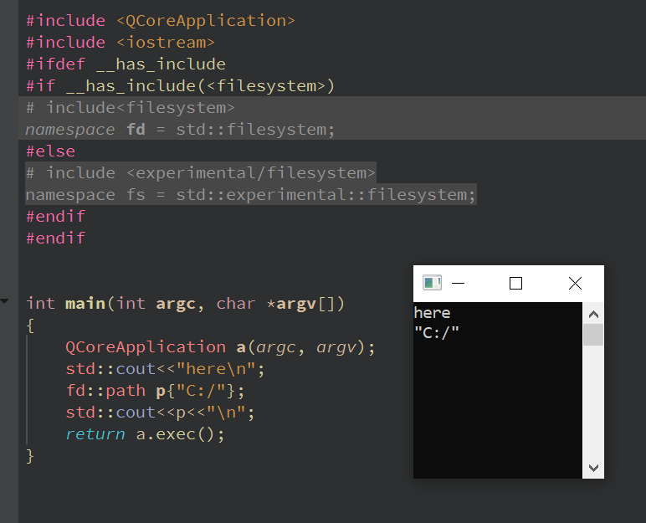

To prevent variables used inside if conditions and switch blocks from polluting the memory space, their scope is limited to the switch block by initializing it inside the if or switch statements, like we do for, for loop. : C++17 features, avoids unnecessary memory leaks, if variable is not required post the if condition.

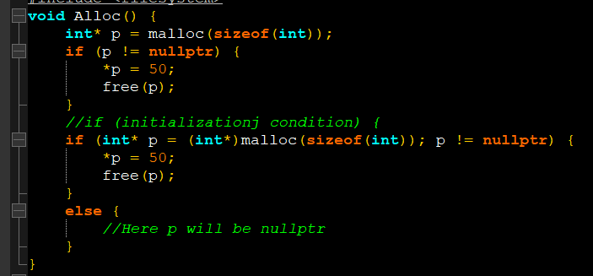

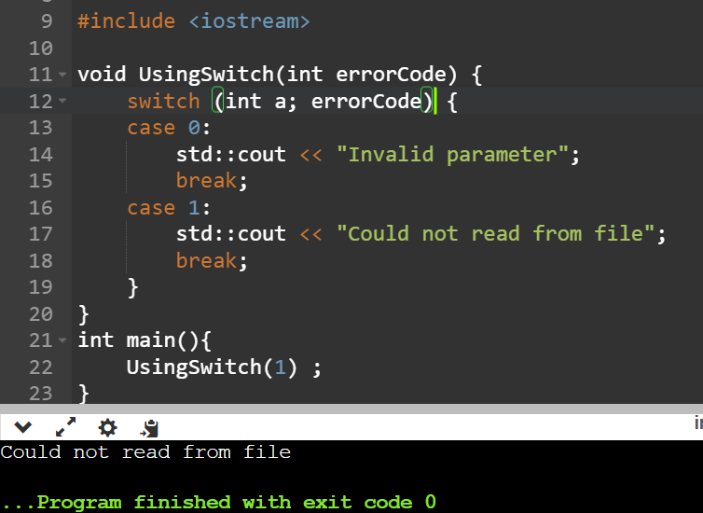

If we have a global variable declared in a header file, and that header file is included in multiple cpp files, then it will lead to linker error as it violates one definition principle for this global variable.

In such cases it is advisable to make that global variable as “extern” and then use it in different files without specifying it.

Or in C++17 way, if that global variable is made “inline” then also it can be used.

Same thing is applicable on static member variables, earlier to initialize a static member variable of a class, we had to create a .cpp file for that class and then initialize the variable outside this class, but now we can initialize the variable within class like other variables like this :  
  
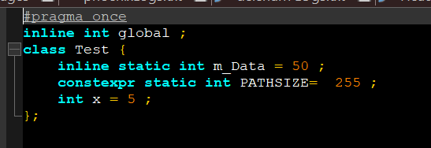

Various ways of using nested namespaces :  
  
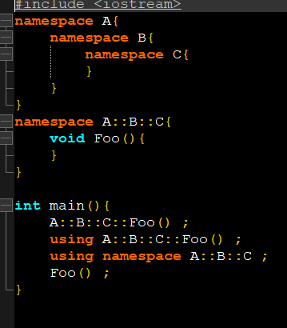

In C++98, a function could advertise what kind of exceptions, it can throw, for ex, the following function can throw float or int type of exception only,  
  
void foo() throw(int, float) {

}

The **noexcept** keyword in C++ is used to declare that a function will not throw any exceptions. It is primarily used for two purposes:

* **Exception Specification**: It specifies that a function will not throw exceptions. This is helpful for both the compiler and the programmer:
  + Compiler Optimization: If the compiler knows that a function won't throw exceptions, it can generate more efficient code, as it doesn't need to include exception handling mechanisms.
  + Documentation: It serves as documentation for the function, indicating to other developers that the function is not expected to throw exceptions.
* **Move Constructors and Move Assignment Operators**: When defining move constructors and move assignment operators, **noexcept** can be used to specify that these operations won't throw exceptions. This is important because standard library containers and algorithms can use move semantics more efficiently if move operations are noexcept.

In C++17, noexcept is part of the function signature, two functions having same signature, but one having “noexcept” keyword written at end will be different from the other.

If a class has a member function that is using lambda function, and that lambda is using this pointer in its capture list, it is advisable to use *this in capture list instead of this, because if the object of the class goes out of scope then the value returned by this function will lead to a crash, because of being a dangling pointer.

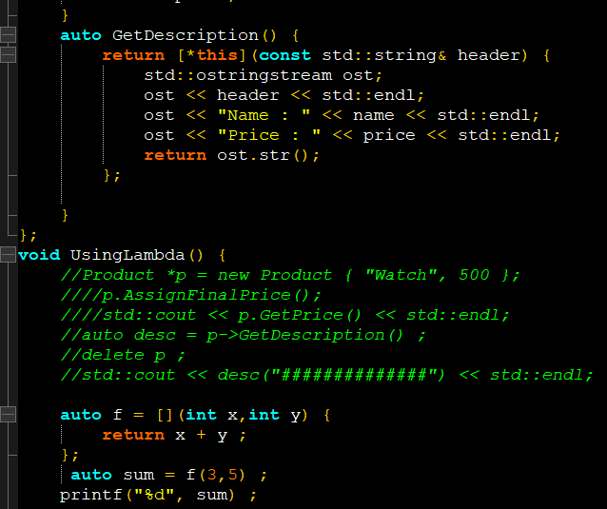

Depending on the context of the lambda expressions, some of them may be automatically available to be contexpr by the compilers, that means their return value will be computed at compile time, no function calls at runtime. (Refer the f function above.)

-Structured bindings in C++ allow you to unpack the elements of a tuple, pair, or other structure into individual variables in a more concise and readable way. It was introduced in C++17 to simplify code that deals with structured data types.

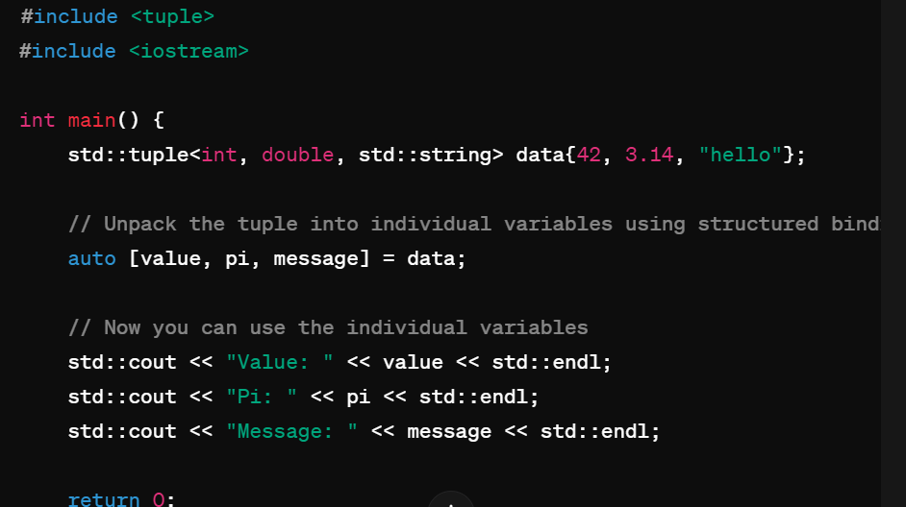

* Alternatively, we can use std::get() for the same thing.
* The **std::get()** function in C++ is used to access the elements of a tuple or a pair by their index. It is part of the **<tuple>** header in the C++ Standard Library.

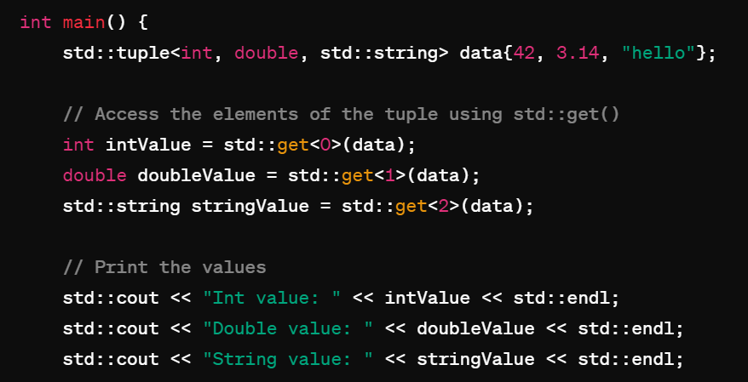

Structured bindings create an anonymous entity which is a copy of the object. This anonymous entity cannot be accessed directly. We can only access the members through the structured binding. Useful when you want to read the data of each member to separate variable or assign.

Simple example :  
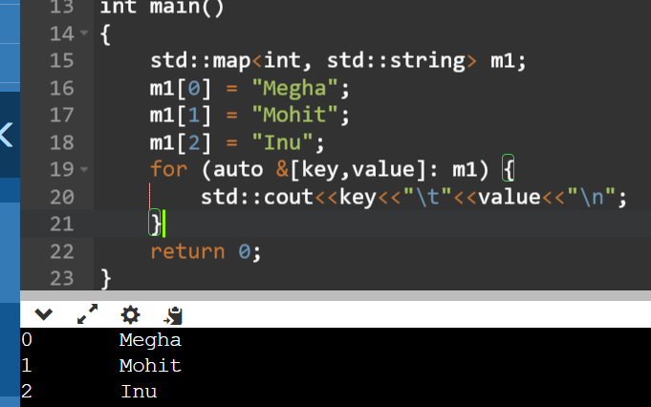

n C++, **.operator** is not a specific operator. Instead, it's a way to invoke overloaded operators explicitly by name.

When you overload an operator in C++, you're essentially defining a function with a specific name that represents that operator. For example, if you overload the **+** operator for a class, you're defining a function named **operator+**.

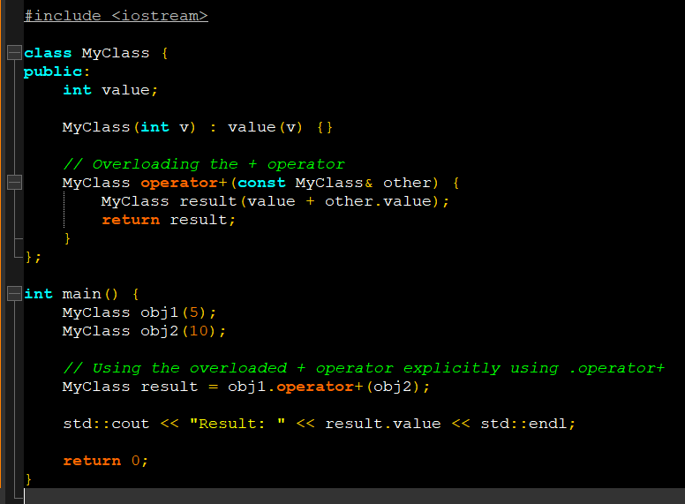

Using function signature : it’s a Microsoft visual studio specific macro : The **__FUNCSIG__** macro is a Microsoft-specific extension that represents the function signature as a string literal.  
  
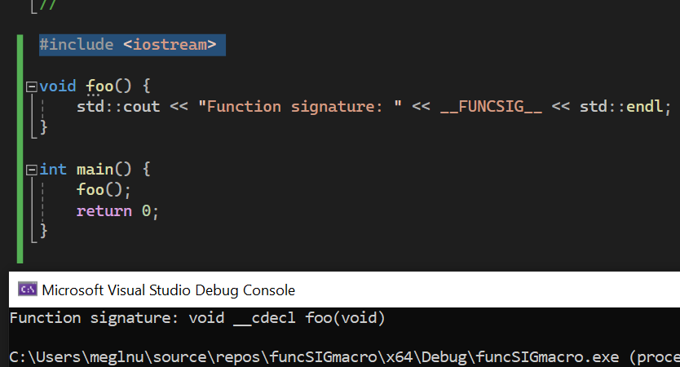

Copy elision, also known as copy optimization or copy omission, is a compiler optimization technique in C++ that allows the compiler to avoid creating unnecessary temporary objects when initializing or returning objects by value.

In certain situations where a temporary object is created, the compiler can optimize the code to construct the object directly in the memory location where it will be used, thereby avoiding the unnecessary overhead of creating a temporary object and then copying or moving it.

Copy elision typically occurs in the following scenarios:

1. **Return Value Optimization (RVO):** When a function returns an object by value, the compiler can optimize the code to construct the return value directly in the memory location of the variable that will receive the return value, eliminating the need for a temporary object.
2. **Named Return Value Optimization (NRVO):** Similar to RVO, but specifically applies when the return value is a named variable declared within the function. In this case, the compiler can construct the return value directly in the memory location of the named variable.
3. **Initialization of Objects:** When initializing an object with another object of the same type, the compiler can optimize the code to directly initialize the object in the memory location where it will be stored, rather than creating a temporary object and then copying or moving it.

Copy elision is allowed by the C++ standard in specific situations, but it is not mandatory. Whether copy elision occurs depends on the optimization level of the compiler and the specific circumstances of the code. However, when copy elision is applied, it can significantly improve performance by reducing unnecessary object construction and copying.

Ex :

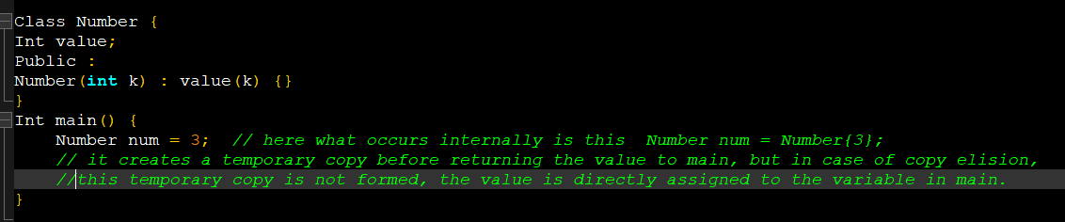



**You**

for copy elision to work is it necssary for class to have copy constructors and move constructors?

Will copy elision occur if a class has deleted move and copy constructors by making them "= delete ?"

Ans : in C++14 standard it didn’t work, if the copy and move constructors were deleted, but in C++17 it works.

Copy elision can still occur even if a class has deleted move and copy constructors. Copy elision is a compiler optimization that involves avoiding the creation of unnecessary temporary objects by directly constructing the object in its final destination.

If a move or copy constructor is deleted, it means that the class explicitly disallows moving or copying instances of that class. However, if the compiler can determine that a temporary object is not actually needed and can be elided, it will still do so, regardless of the deleted constructors.

CONCLUSION : in c++17 copy elision has become mandatory, it is mandatory for expressions where you are initializing an lvalue with an rvalue, and those expression would be :

-when a function returns a temporary by value.  
- when an object is initialized by rvalue.  
- when a function that accepts an lvalue is invoked with rvalue argument.

TEMPLATES :

The compiler internally generates multiple copies of the max function according to the arguments.

When we checkout assembly code from project -> properties at end -> C/C++ -> Output files -> Assembly output -> assembly with source   
and then run the program again, then .asm file is generated in debug folder of source project, this is the assembly code where we can see multiple function calls for max function.  
  
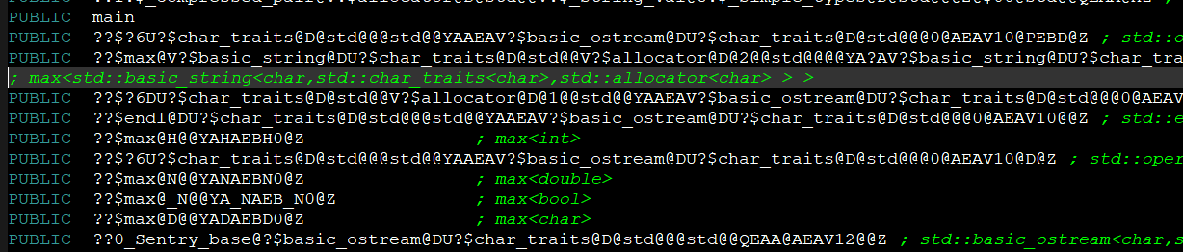

If the calls to max function are commented out, the function max is not generated in the assembly code, this means that the function is present (exists) only if its called, otherwise not.

This process is called instantiation of template function according to type T, and it happens at COMPILE time.

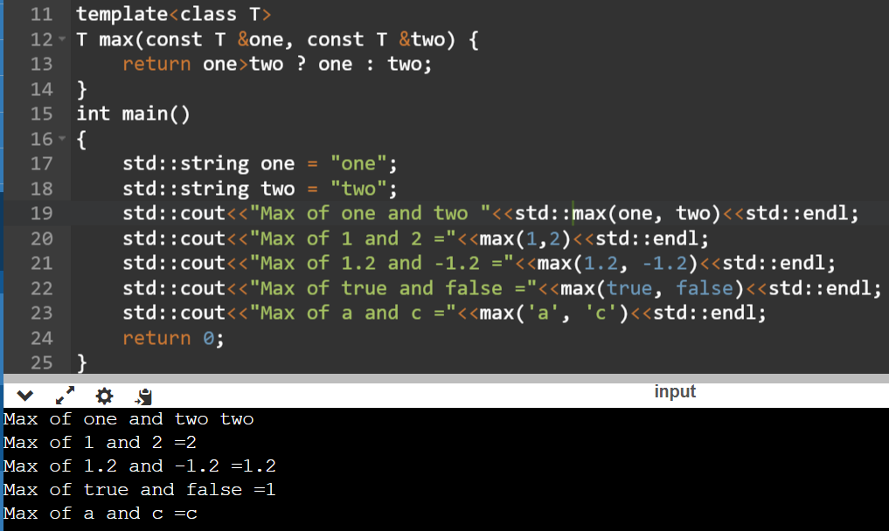

Works fine in visual studio :

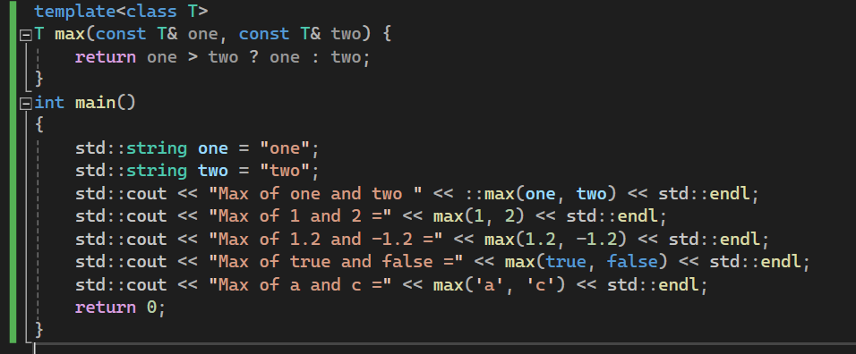

REMEMBER THERE IS A SPACE BETWEEN template <typename T>

Good assignment :  
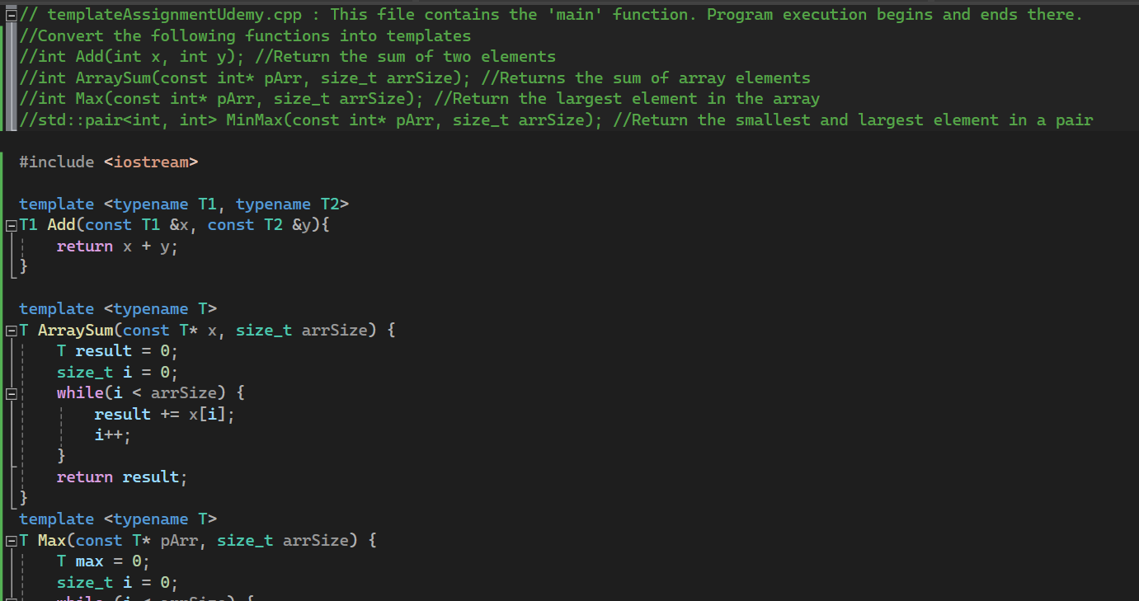

Since template instantiation is done at compile time, the complete definition of the template function should be visible to the compiler that is why they are defined in header files.

This way, while calling function, you can overwrite the template deduction using max<double> while calling, now template max function will not deduce functionality from arguments but from parameter specified in <>

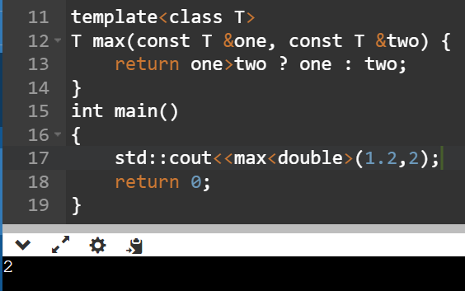

Custom comparator for priority queue

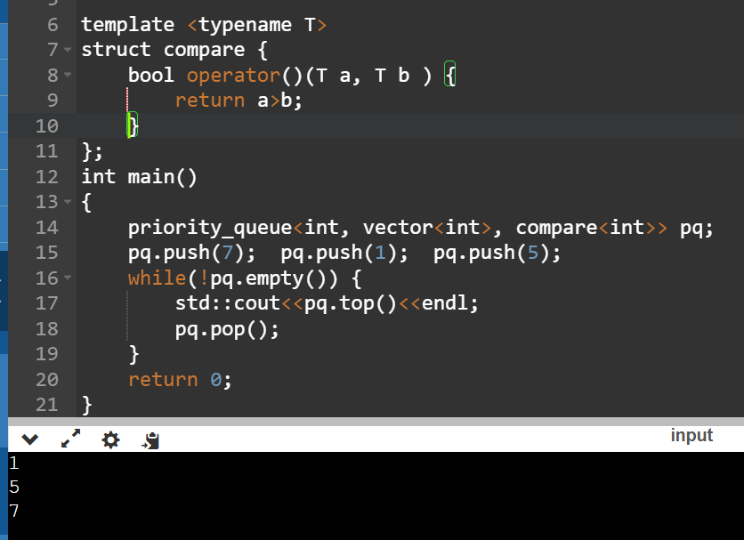

Explicit template specialization is used when our default definition of template function doesn’t provide correct results for certain datatypes.

Or implementing an algorithm more optimally for a specific datatype.

EXPLICIT SPECIALIZED FUNCTIONS MUST BE DEFINED IN A .cpp file, not in header file.

Explicit template syntax and implementation, didn’t understand.

Non template type arguments : The value that you specify in this way should be a const value, if u create a variable called I and pass it to print<i>() like this, it wont work. Also these non template type arguments are const, if you try to modify them within the function body, like number++, it also wont work.

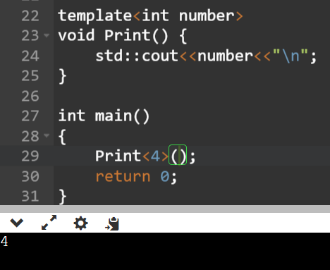

Application : The non type template arguments have been used in the standard library to get std::begin and std::end iterators for static arrays. Their, the size of the static array is given as this kind of argument.

Convert the following functions into templates

1. int Add(int x,int y) ; //Return the sum of two elements
2. int ArraySum(const int *pArr, size_t arrSize); //Returns the sum of array elements
3. int Max(const int *pArr, size_t arrSize) ; //Return the largest element in the array
4. std::pair<int,int> MinMax(const int *pArr, size_t arrSize) ; //Return the smallest and largest element in a pair

Take care to avoid copies of user-defined objects wherever applicable.

For the functions in questions 2,3 & 4 in Assignment I above,

1. Modify to accept array by reference.
2. Specialize for an array of strings (const char *). Observe, the limitations.
3. Specialize for an array of std::strings. Compare with the previous implementation.
4. Define the specialized functions in a .h file and include it in multiple source (.cpp) files. Observe what happens.

Difference between parameter and arguments : parameters are what are declared in the function declaration or definition , arguments are the actual values that are passed to the function when we call it.

-Perfect forwarding :

Perfect forwarding is a C++ feature introduced in C++11 that allows functions and constructors to forward arguments to other functions or constructors with the exact same lvalue/rvalue characteristics as the original arguments. It enables preserving the value category (lvalue or rvalue) and constness of the arguments when passing them through multiple layers of function calls.

Perfect forwarding is typically achieved using universal references (also known as forwarding references), which are function parameters declared using the **&&** syntax in a template parameter list. Universal references can bind to both lvalues and rvalues, and their type can be deduced using template argument deduction.

Perfect forwarding is commonly used in generic programming contexts, such as writing forwarding functions, wrapper classes, and generic container types, where preserving the original argument types and value categories is essential.

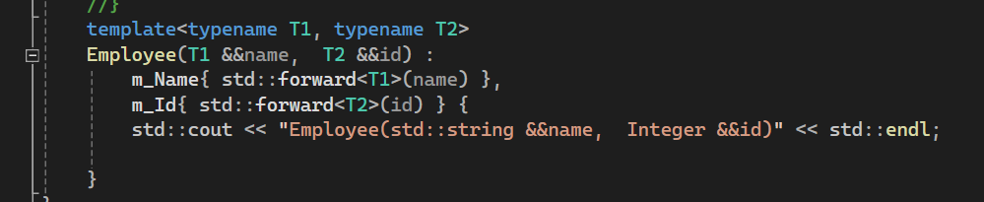

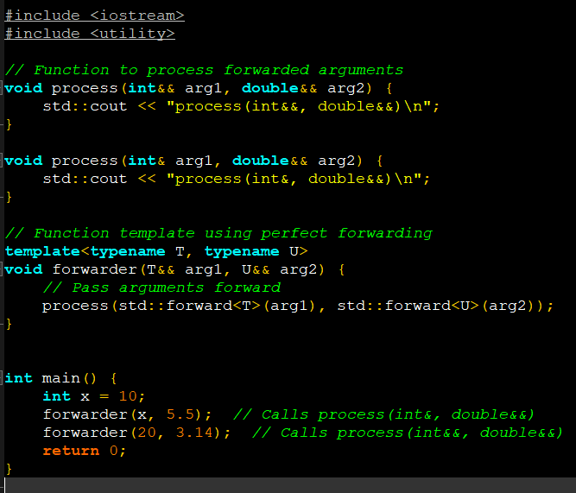

Variadic templates : Variadic templates are functions and classes that can accept arbitrary number of arguments.

Eg: printf() function of C language, it internally used MACROS which are not type safe, and secondly such a function cannot accept references as arguments.

Here, it is implemented like

Template <typename T, Params …>  
Void print(T &x, Params args) {  
 While(args.size()>0) {  
 std::cout<<args<<”,”;

}

Print()

}

Something about Qt:

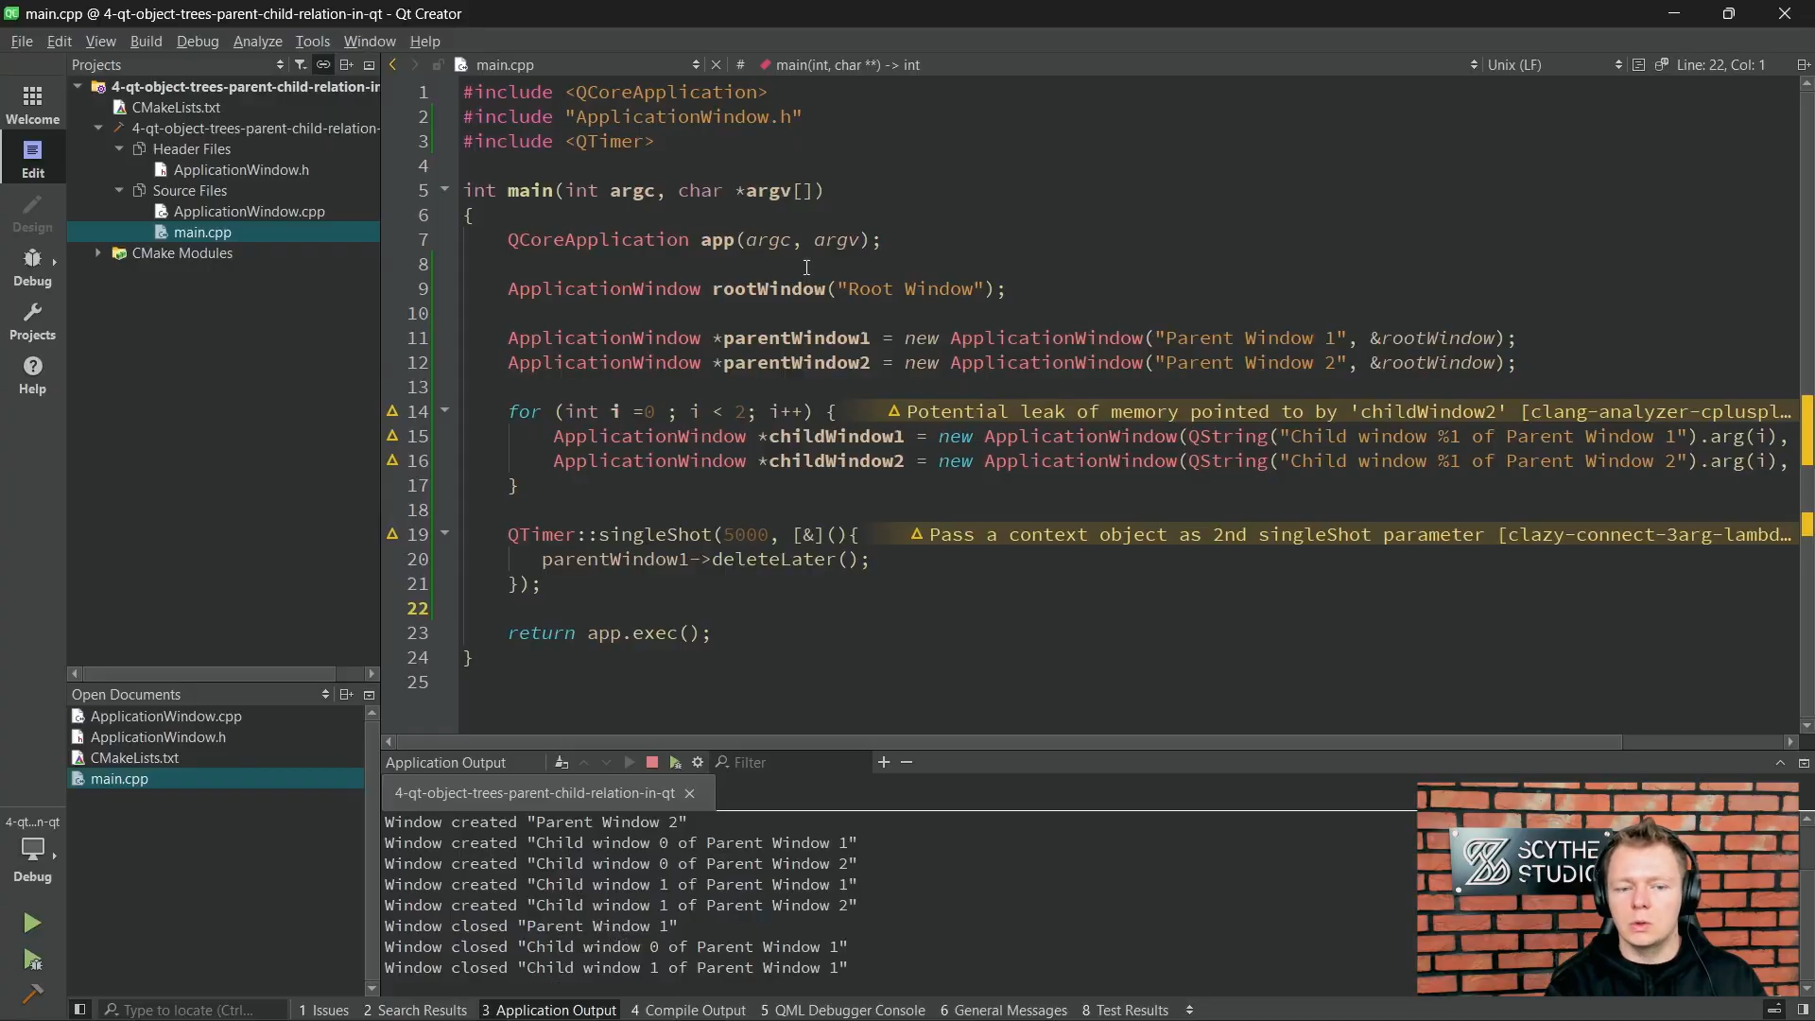

STL by Love Babbar :  
[Lecture19: C++ STL in 1 Video (Re-Uploaded) (youtube.com)](https://www.youtube.com/watch?v=WgMPrLX-zsA)  
  
std::array   
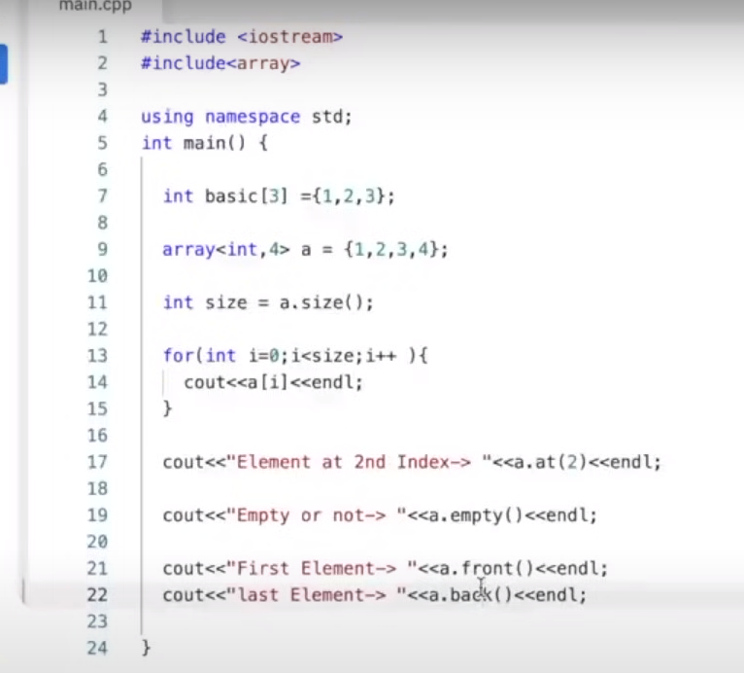

Difference between size and capacity of vector. Size() is currently occupied, capacity is how much more it can accommodate before reallocation takes place. This reallocation process can be time-consuming, so it's more efficient to preallocate memory when the expected number of elements is known in advance, using the **reserve()** member function.

No, erasing elements from a vector does not trigger reallocation by itself. When you erase elements from a vector, the size of the vector decreases, but the capacity remains unchanged. The vector doesn't automatically shrink its capacity to match its new size.  
However, you can explicitly request a reallocation to reduce the capacity to match the size of the vector using the **shrink_to_fit()** member function. This function is not guaranteed to reduce the capacity, but many implementations will attempt to do so.

No, the **clear()** operation on a vector doesn't automatically reduce its capacity. The **clear()** function removes all elements from the vector, but it doesn't affect the capacity. After calling **clear()**, the vector still retains its original capacity.

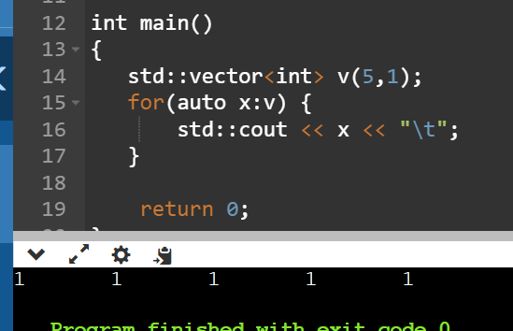

Template metaprogramming :   
[Intro to Template Metaprogramming - Template Metaprogramming in C++ - E1 (youtube.com)](https://www.youtube.com/watch?v=VBI6TSo8Zog&list=PLWxziGKTUvQFIsbbFcTZz7jOT4TMGnZBh)  
  
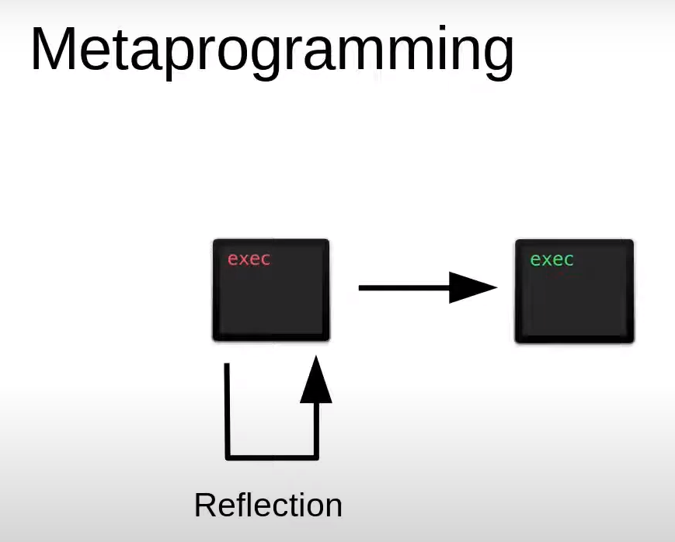

If we want to print the value held by a pointer rather that the pointer’s address, we can modify template definition like below:  
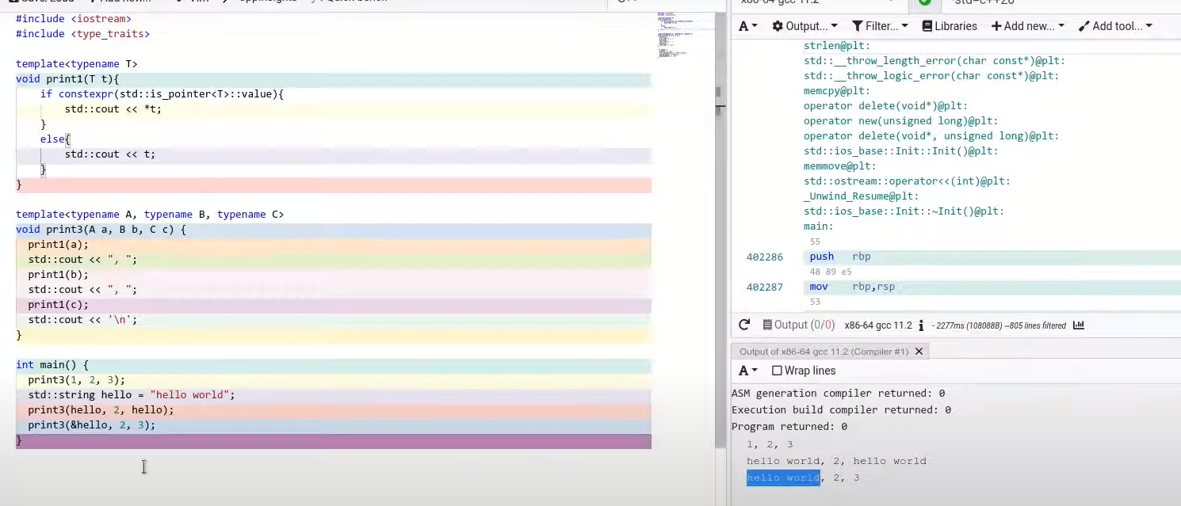

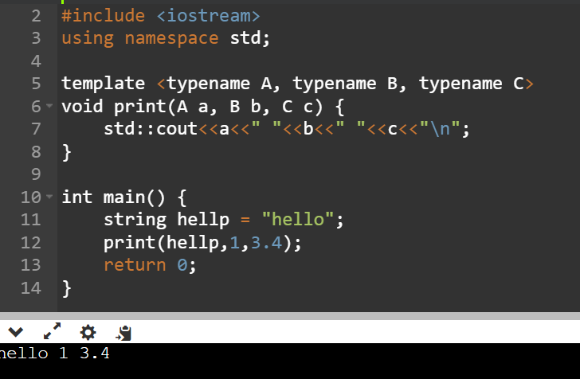

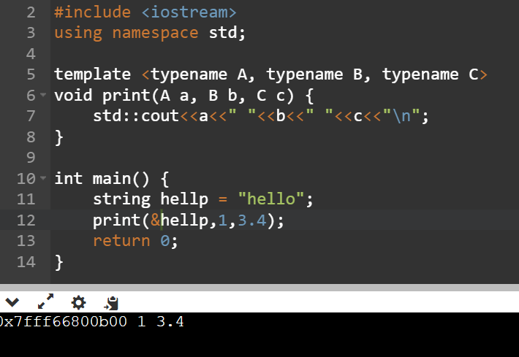  
  
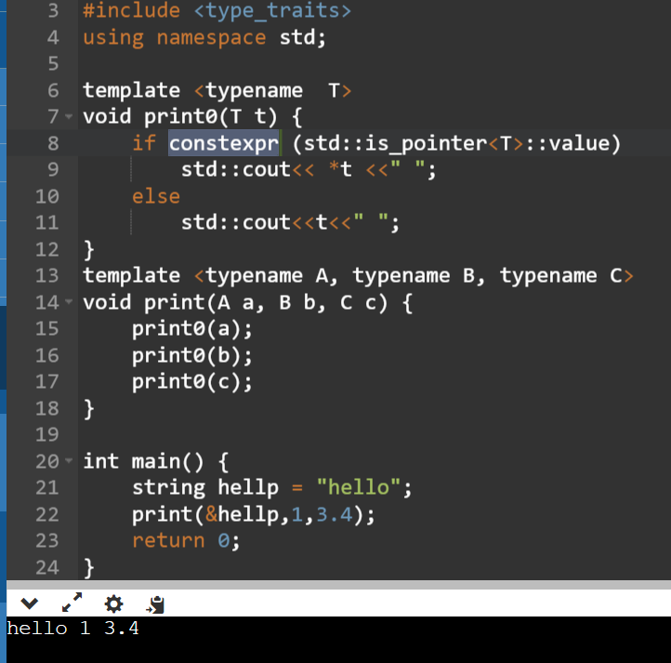

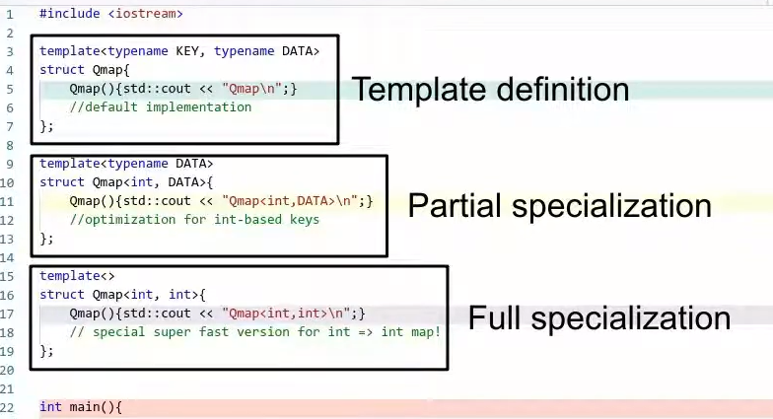

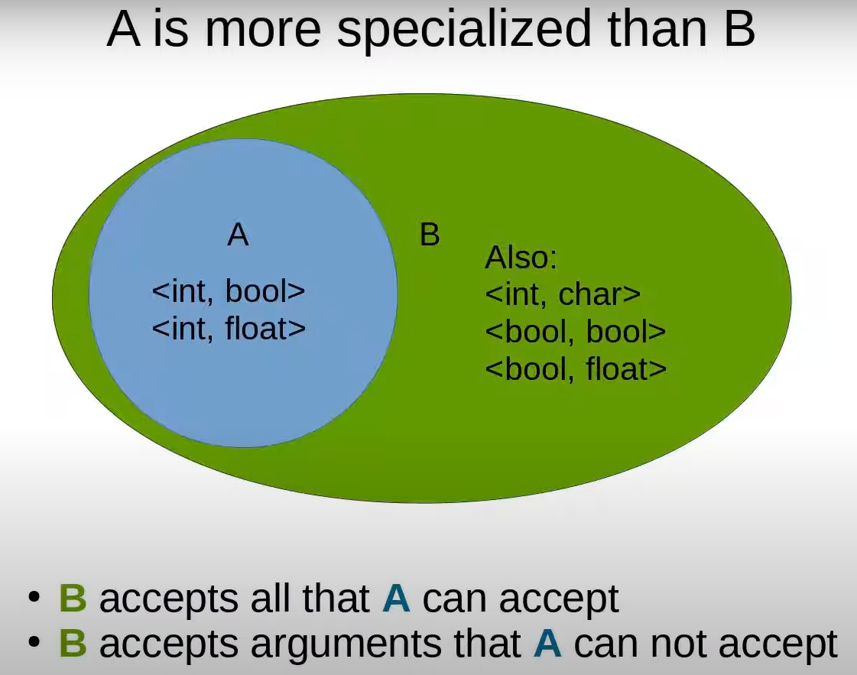

This not working for floating points   
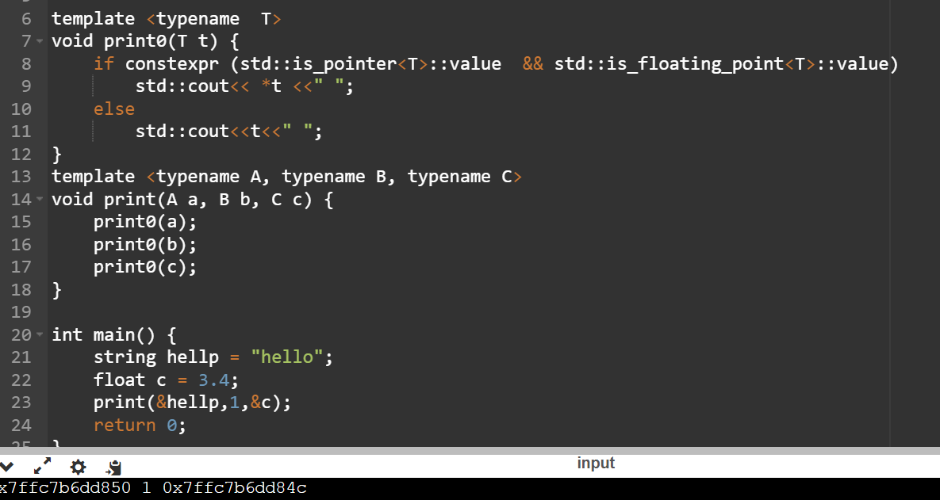  
  
Now it works correctly :  
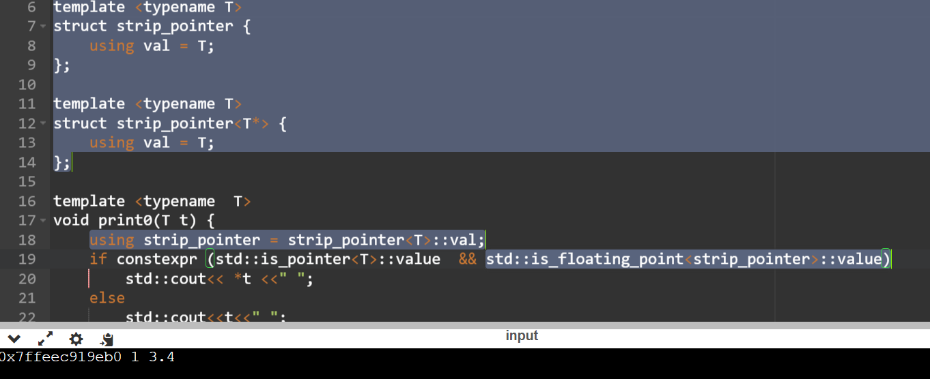  
whole code :  
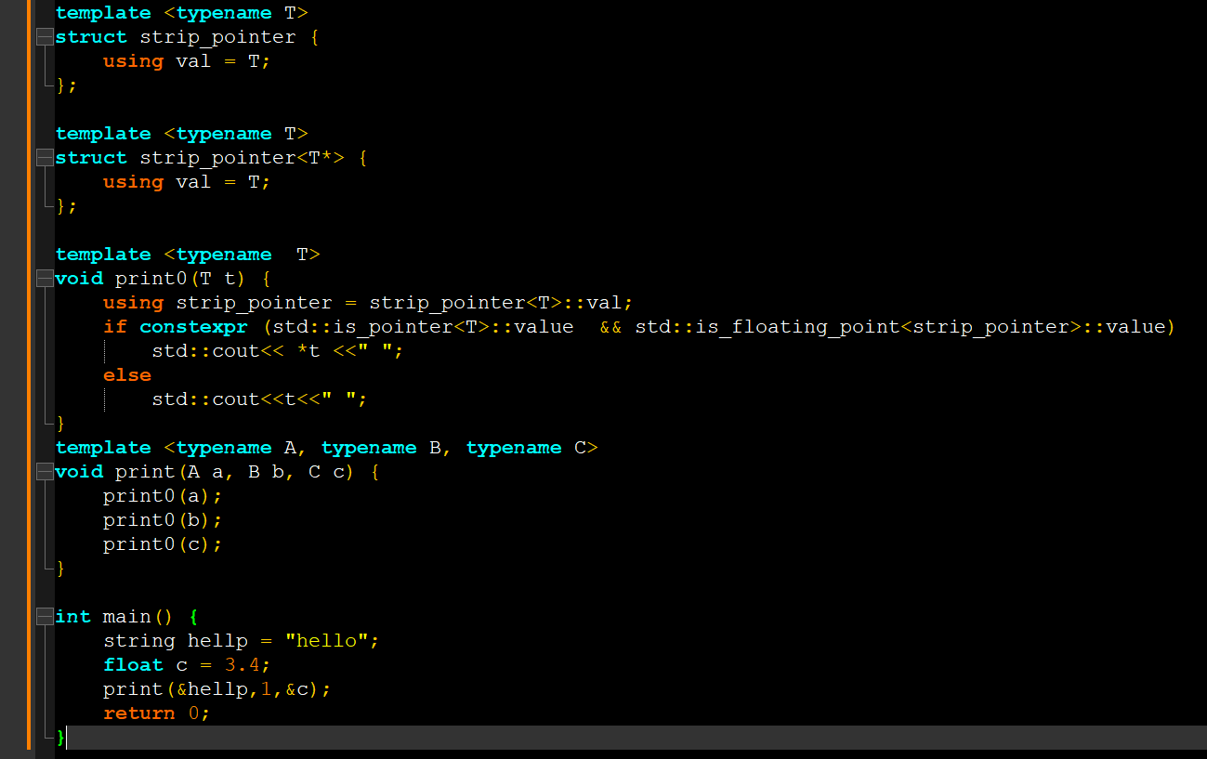  
  
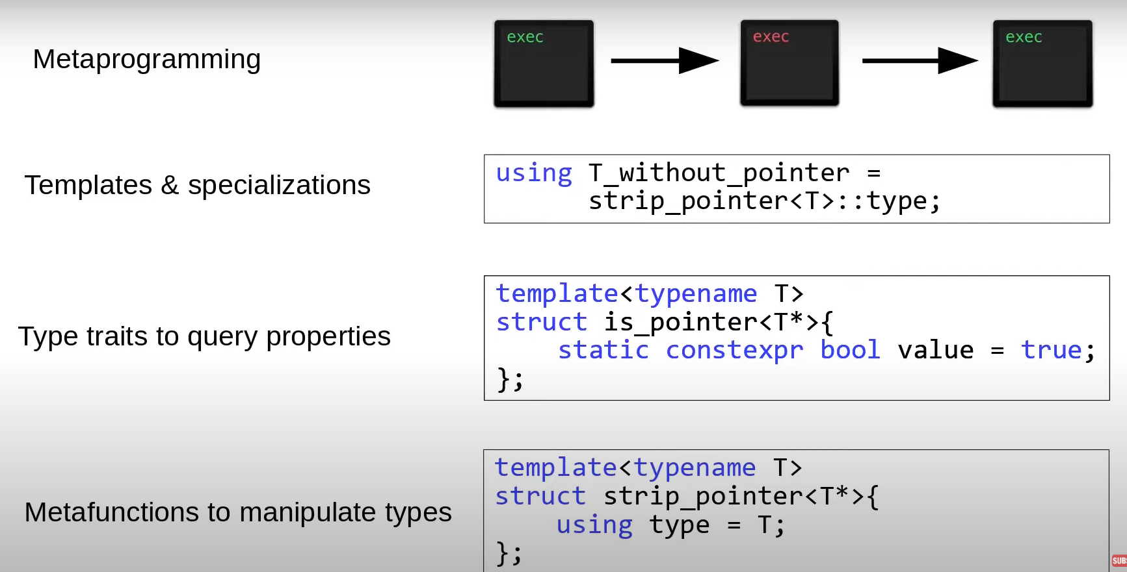  
  
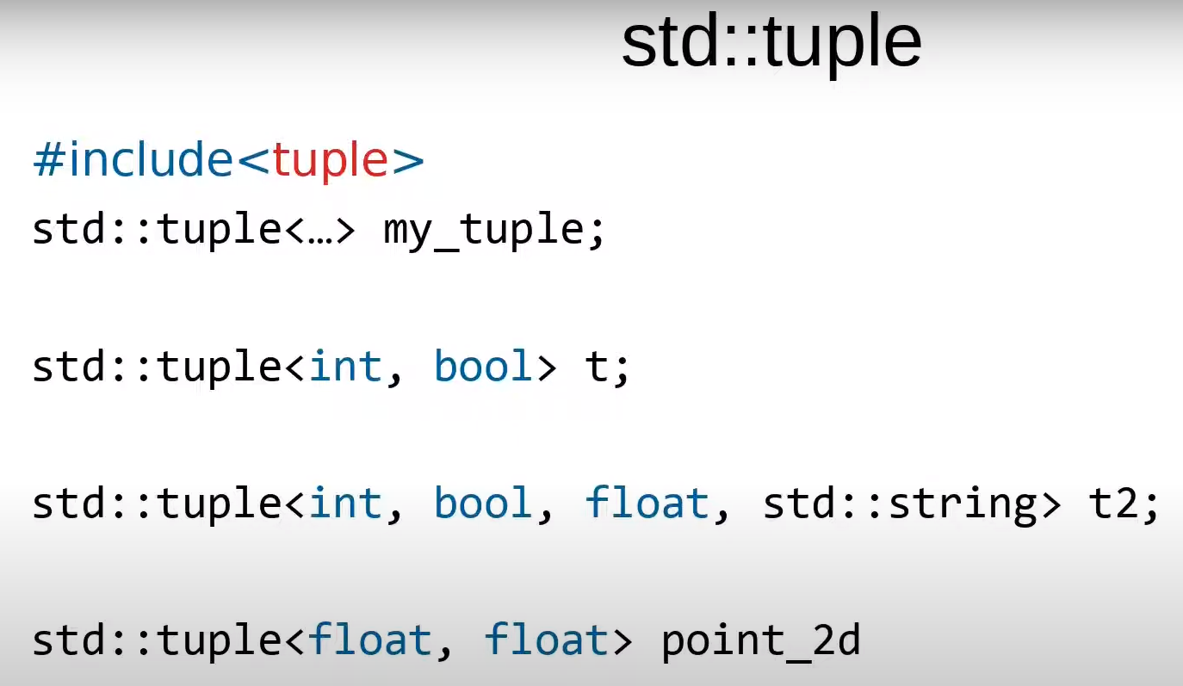  
  
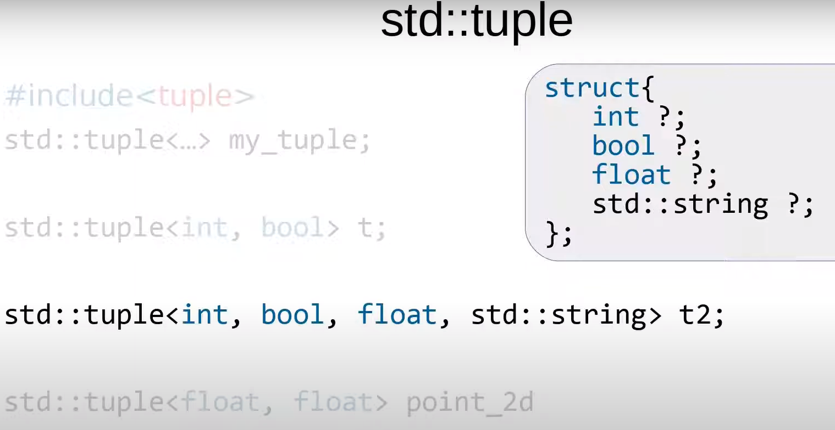

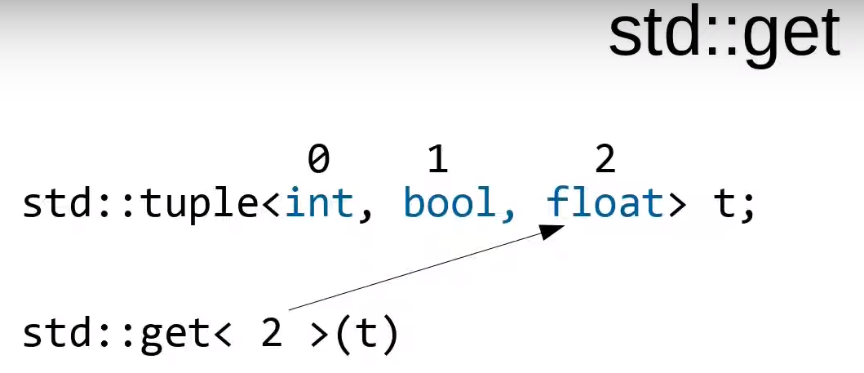

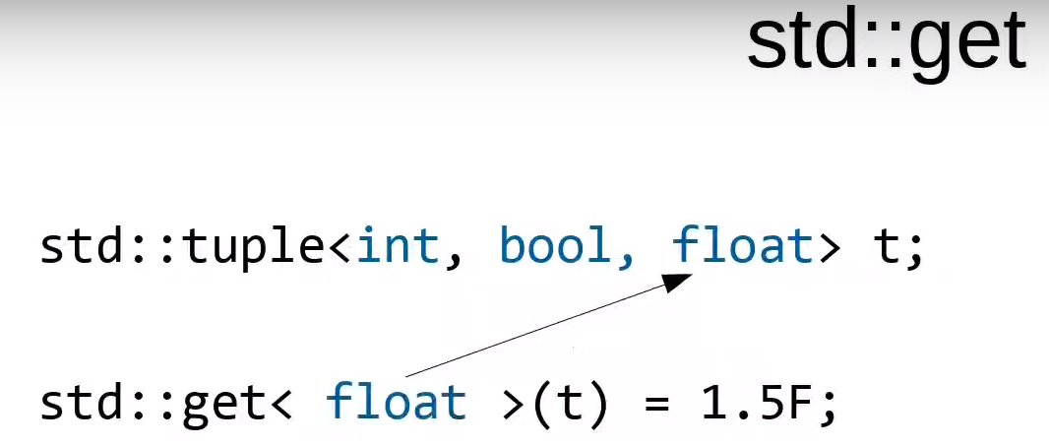

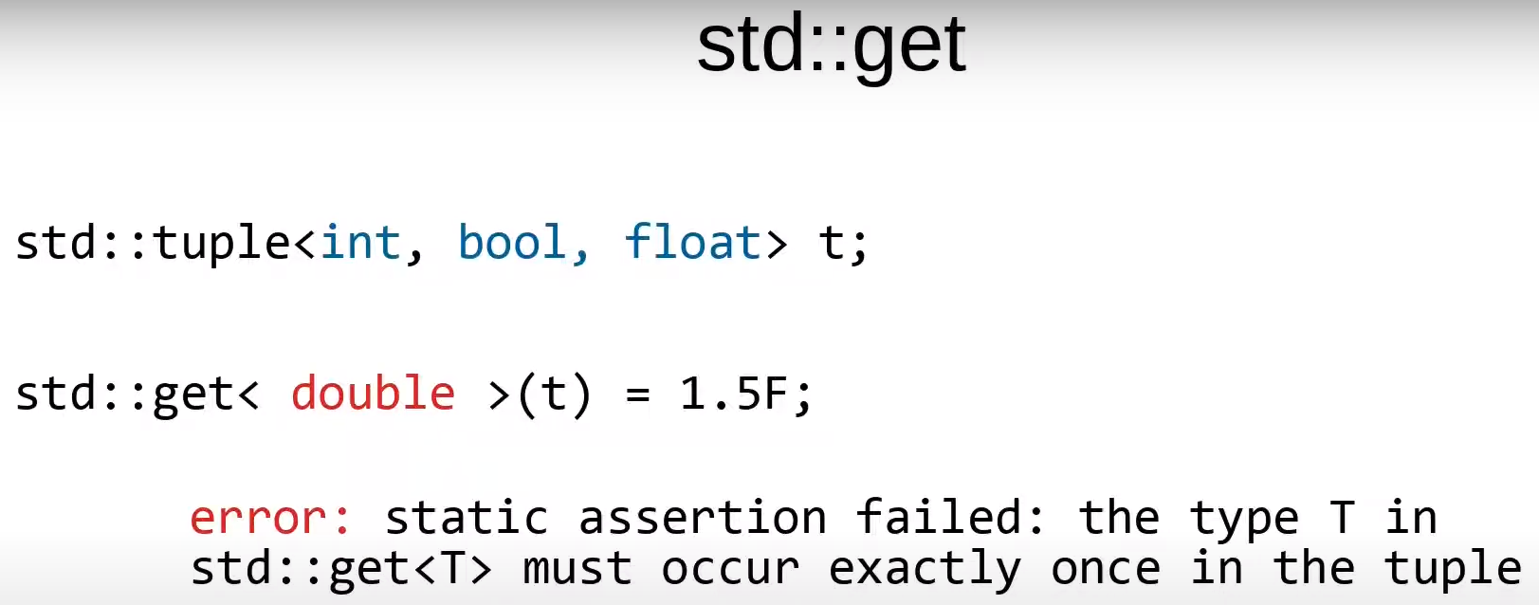

We are going to write a function which will check whether a particular type is present in the given tuple or not.

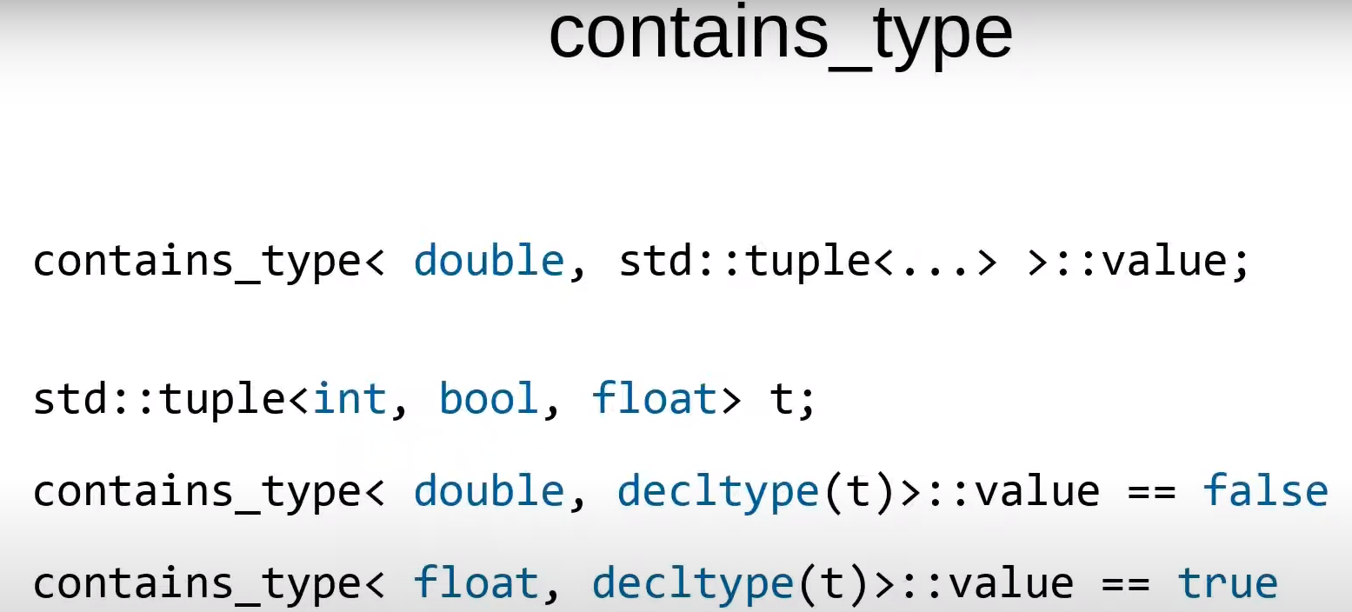

The **decltype** keyword in C++ is used to determine the type of an expression or entity at compile time. It stands for "declare type" and allows you to declare a type that matches the type of a given expression without actually evaluating the expression.

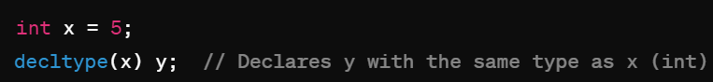  
  
  
  
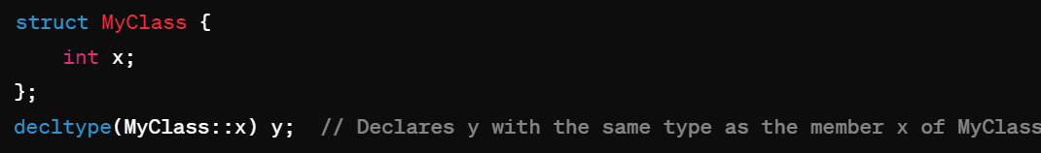  
  
int x = 5;

decltype(x + 3) y; // Declares y with the same type as the result of the expression x + 3 (int)  
  
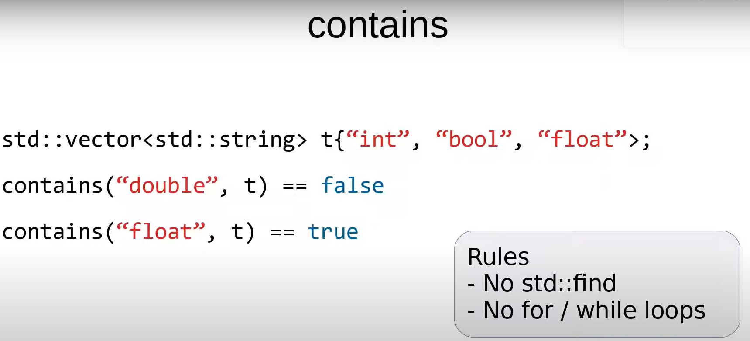

if you are new to template metaprogramming you should first write an implementation for runtime environment, for eg if you were given a string with these values and you had to check their existence in a vector.

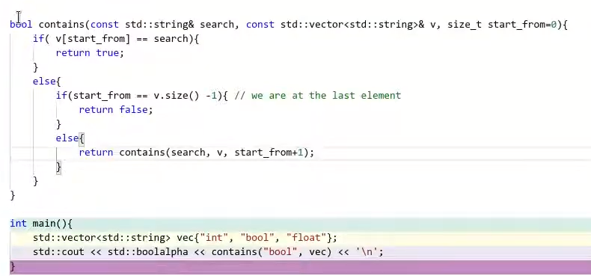

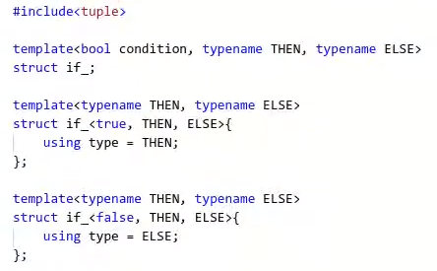

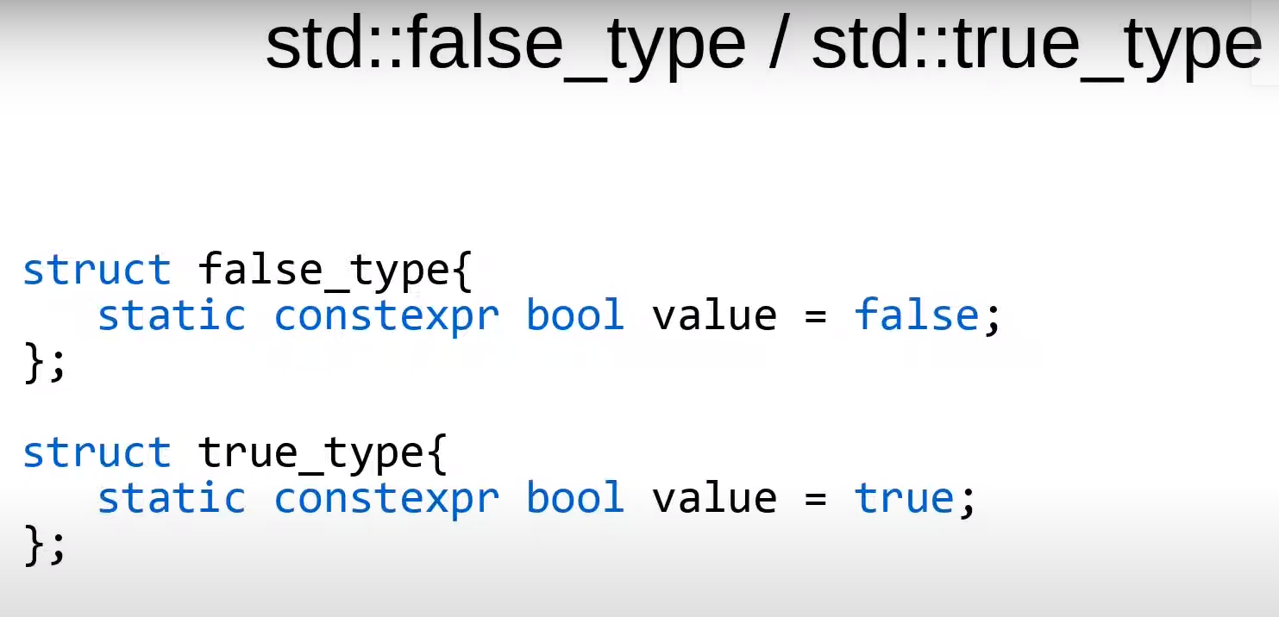

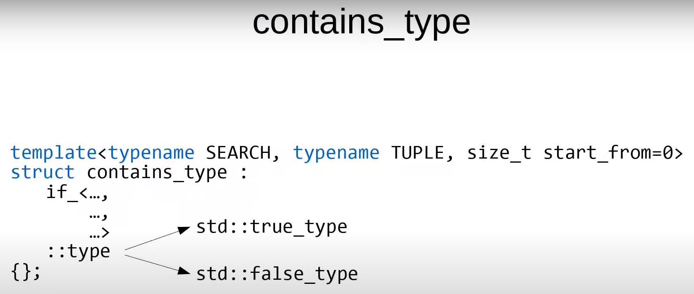

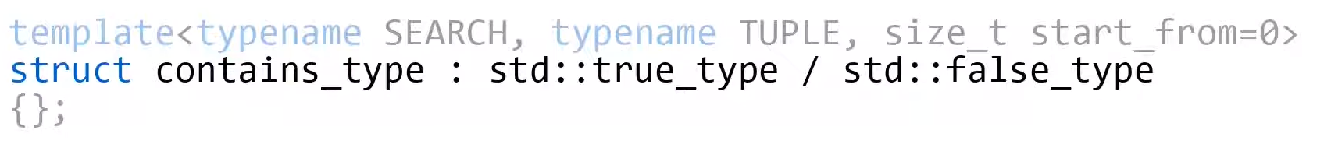

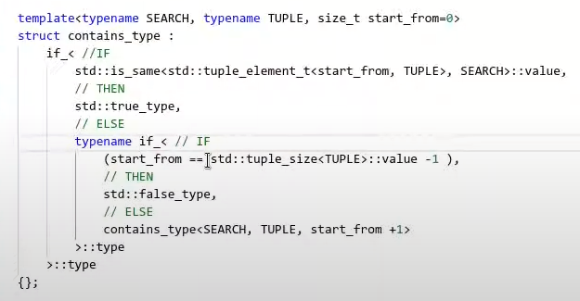

Type Ids and typeInfo :  
  
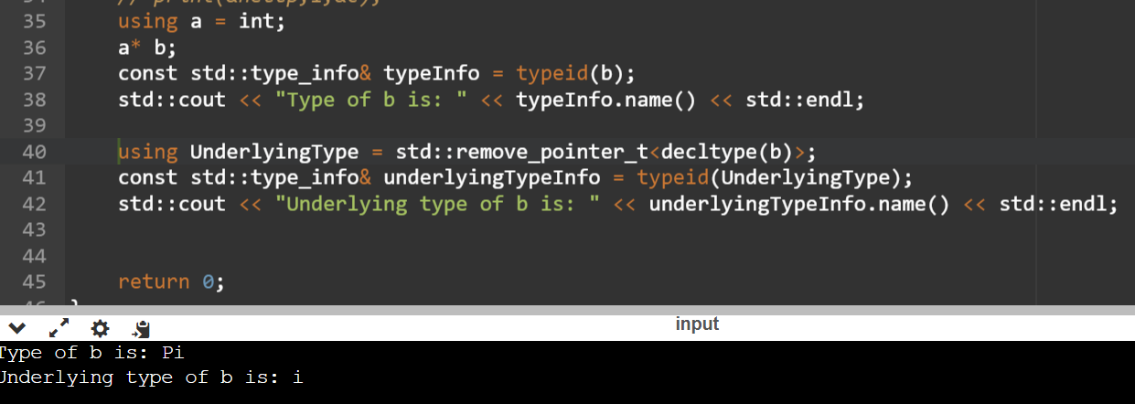

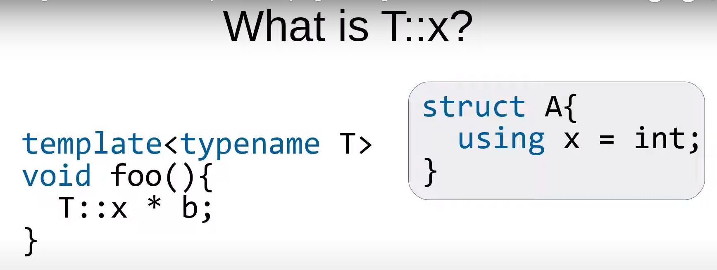

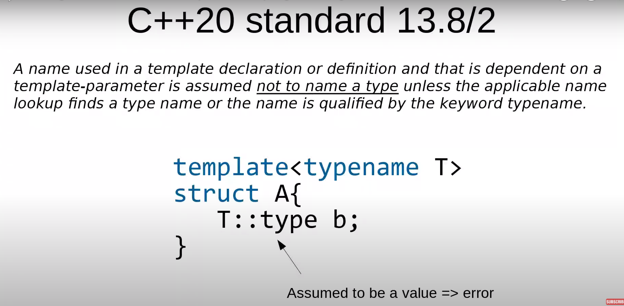

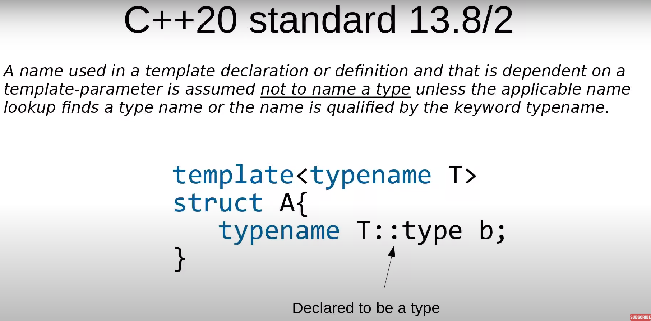

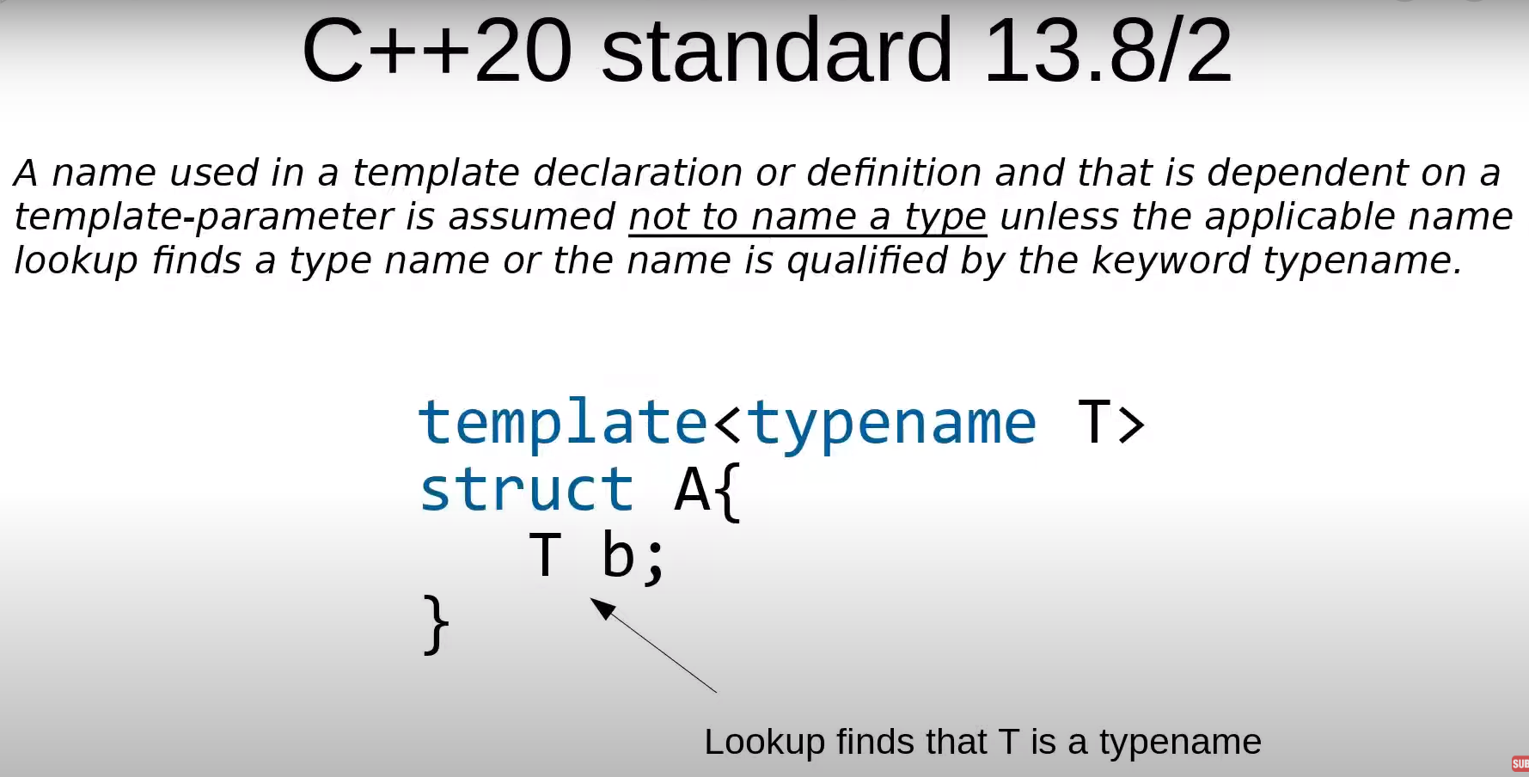

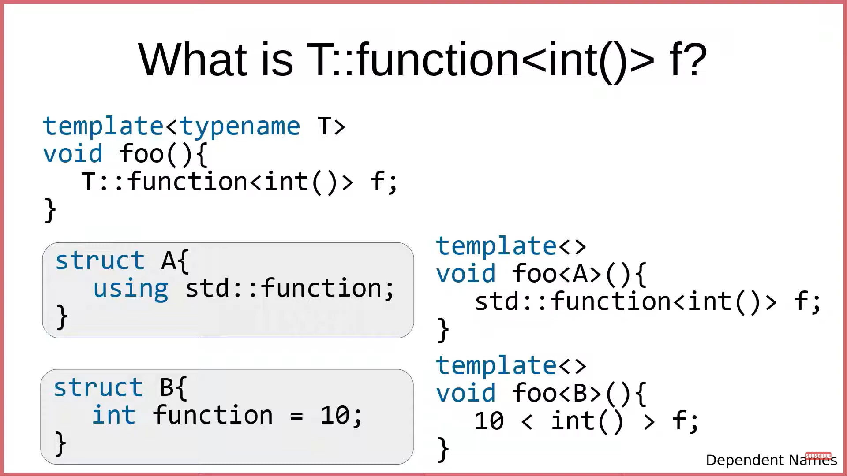

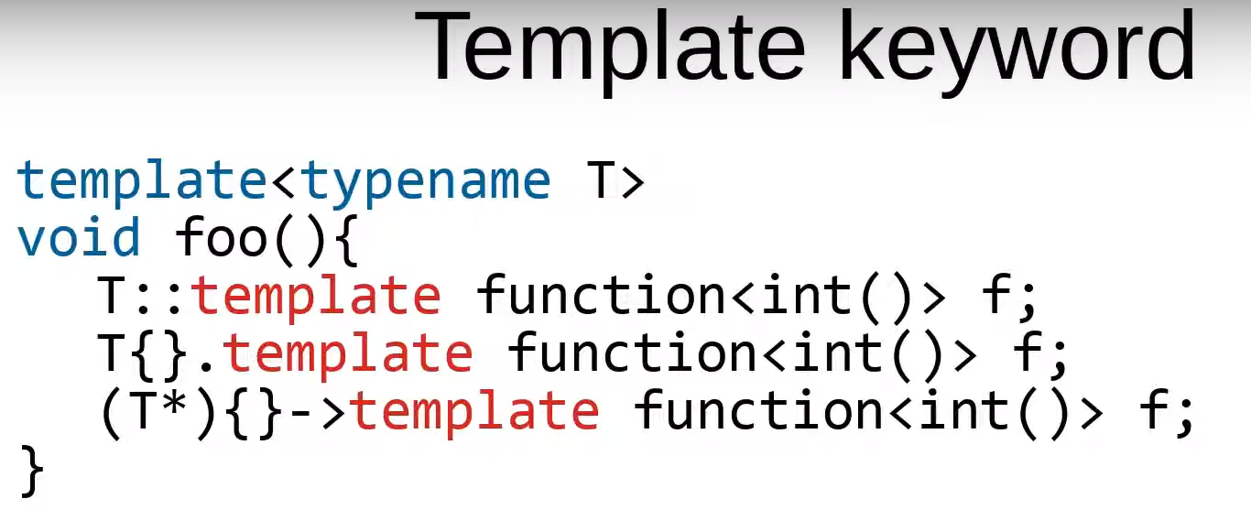

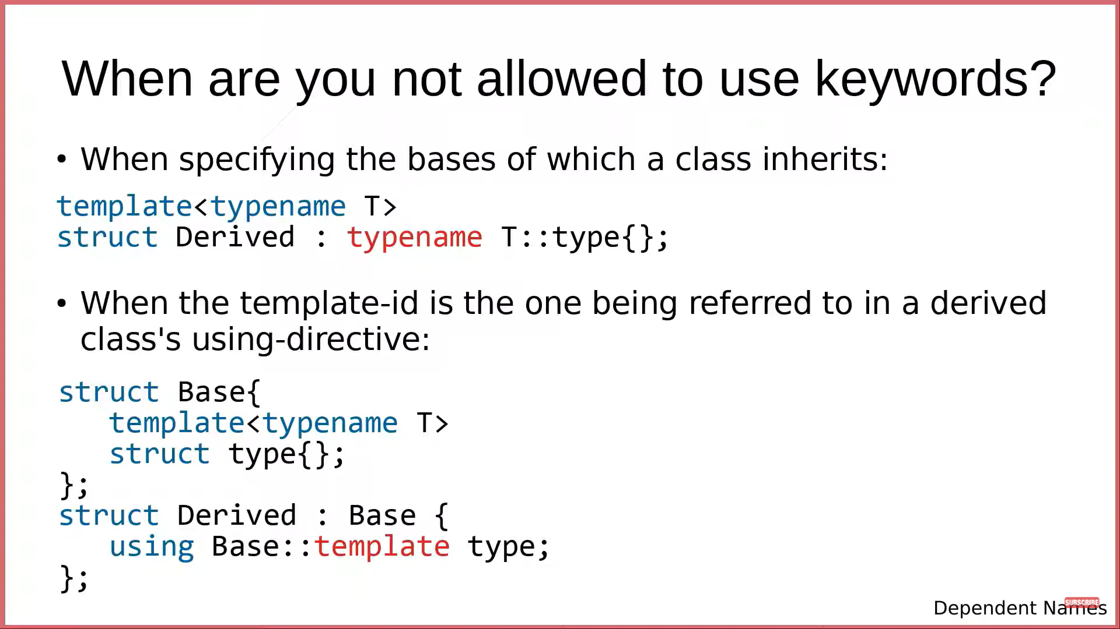

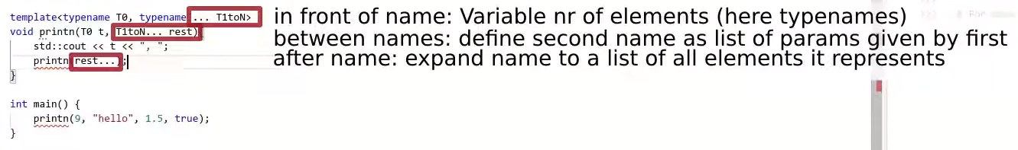

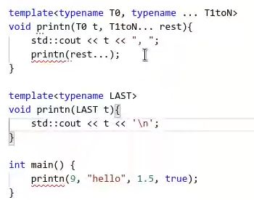 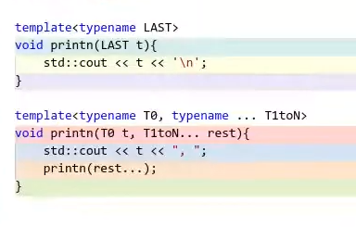 Now it works

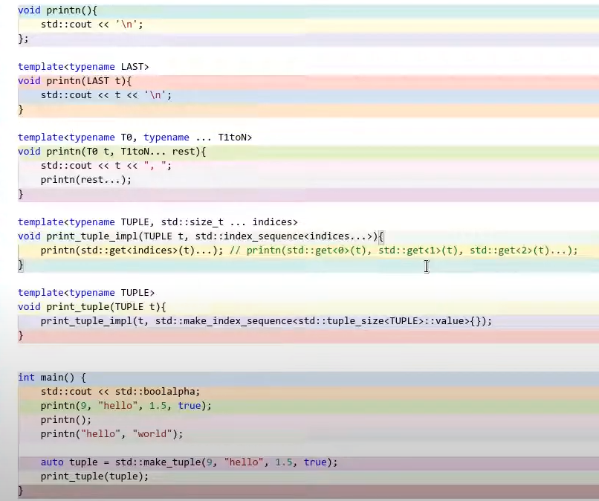

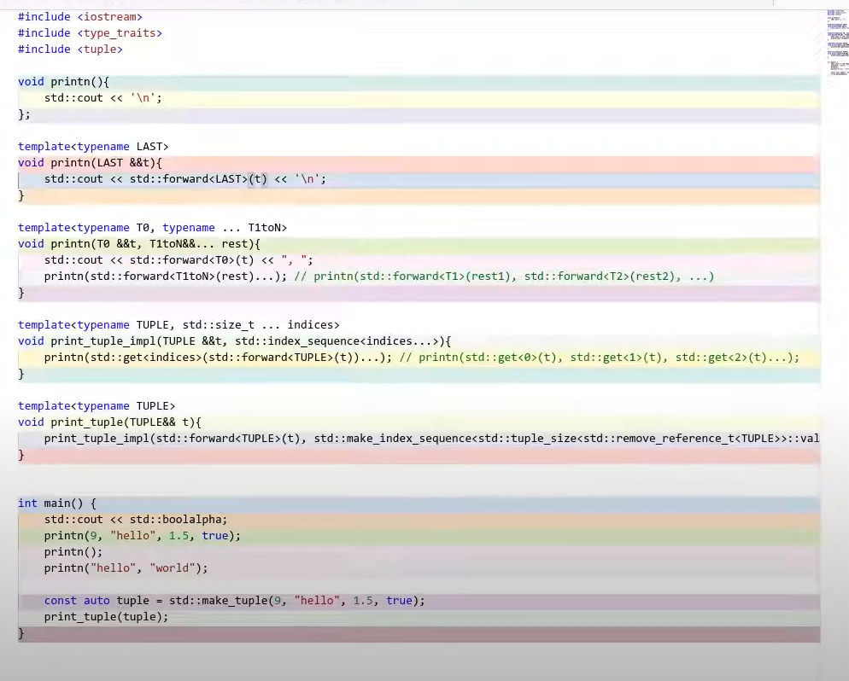

Sorting algorithms :  
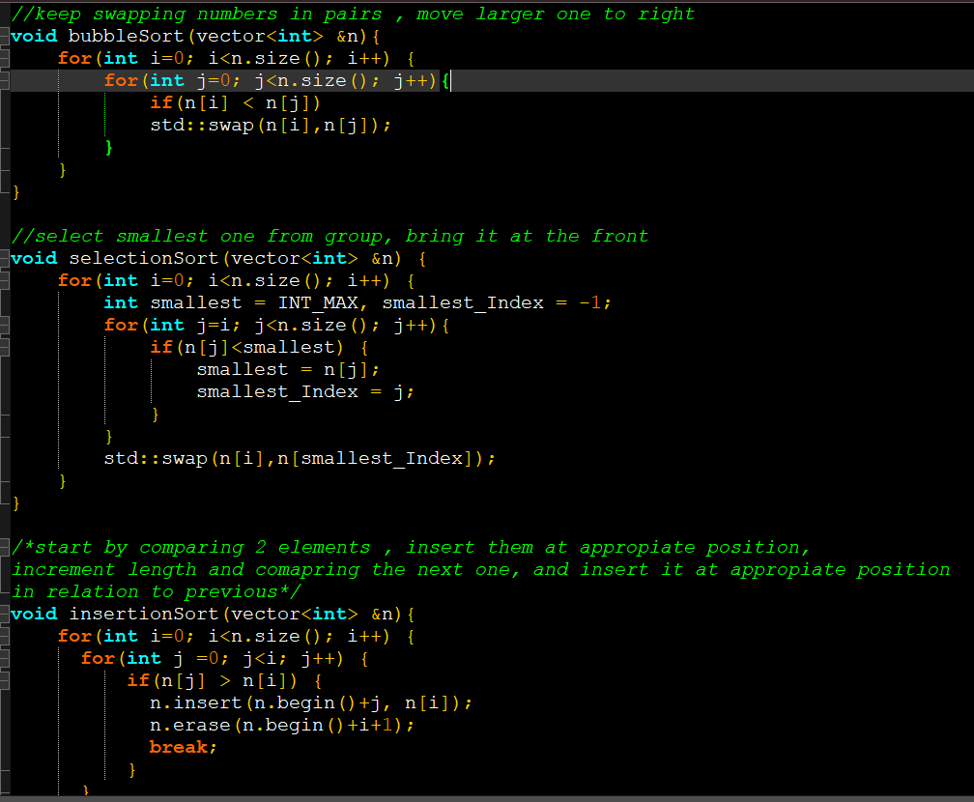

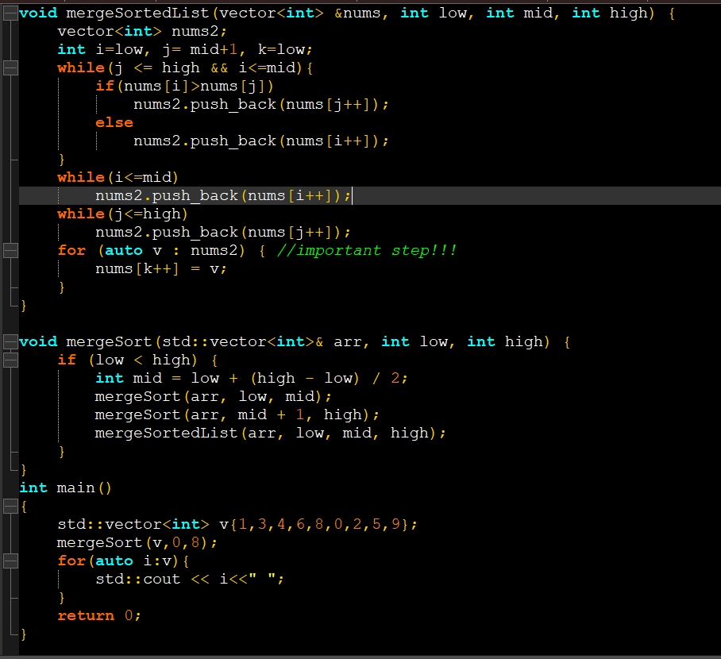

Type casting in C++

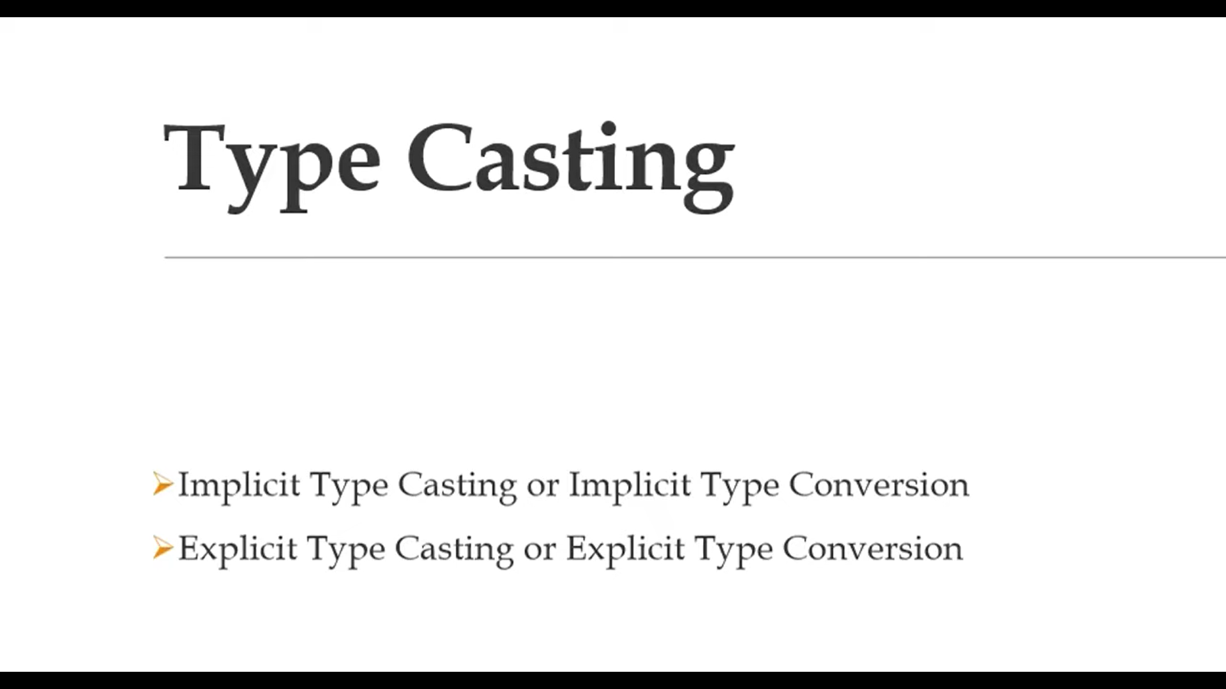

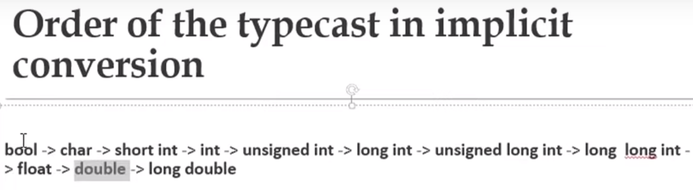

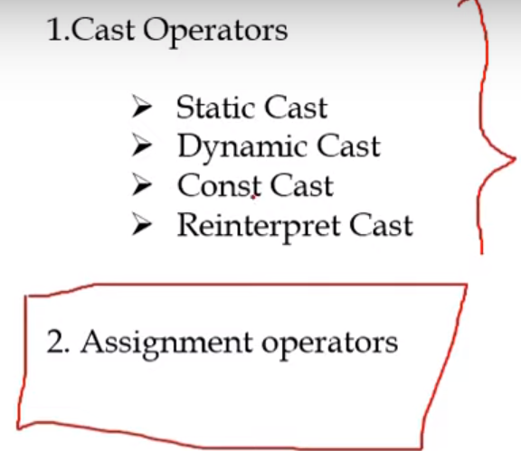

This is explicit assignment type casting example :  
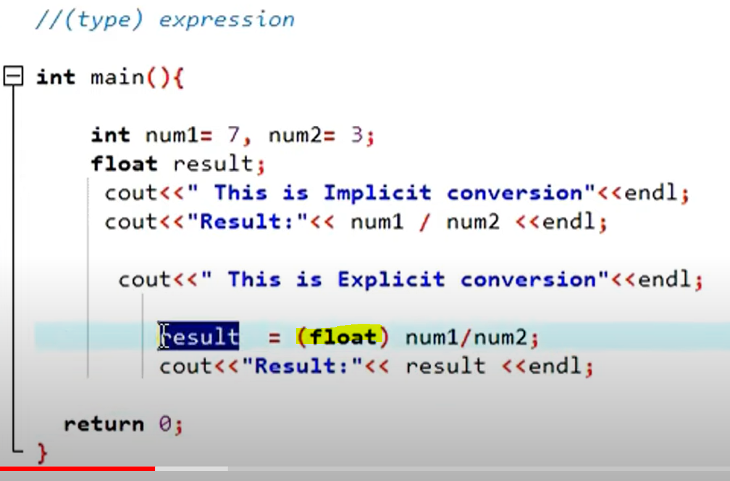

Same as implicit casting. Only safer because done by user at compile time.

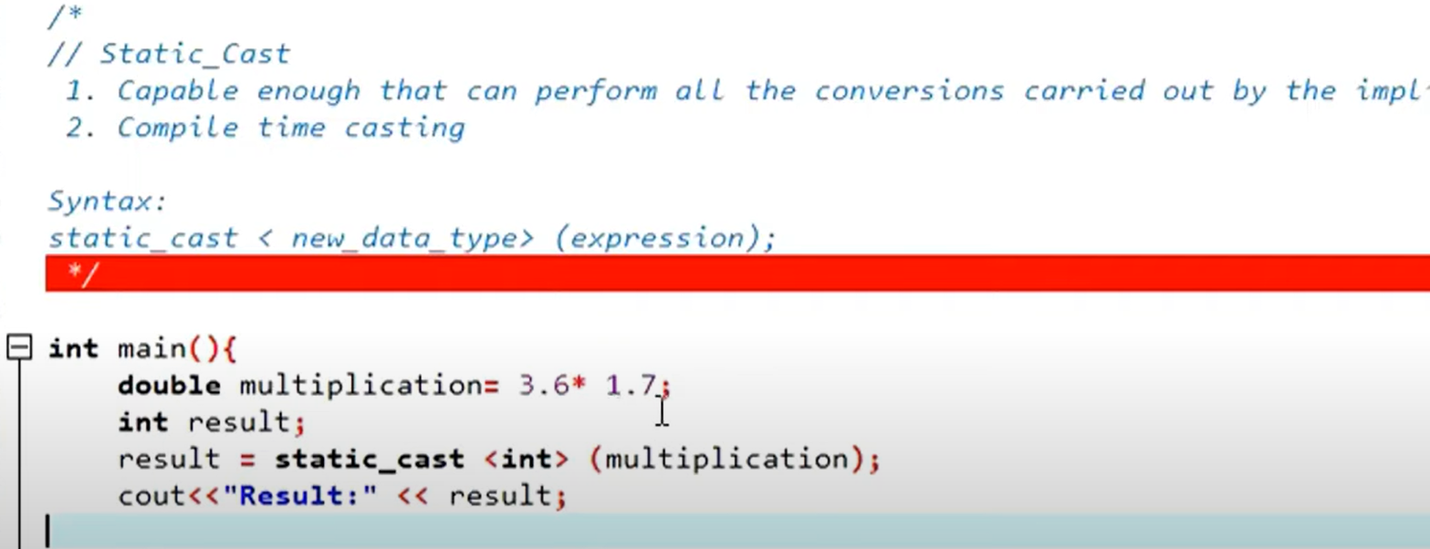

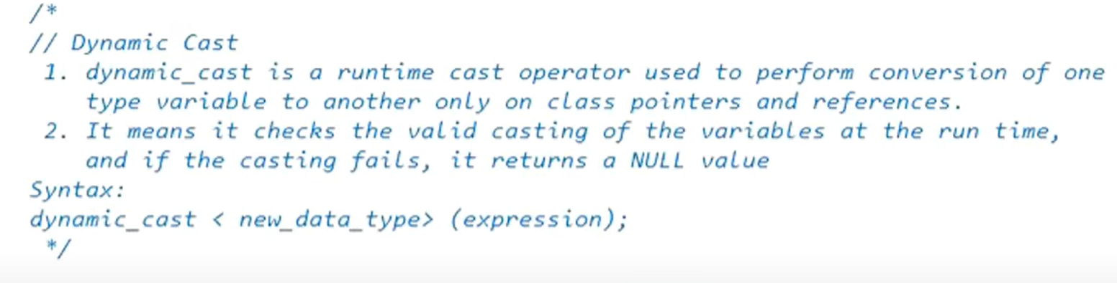

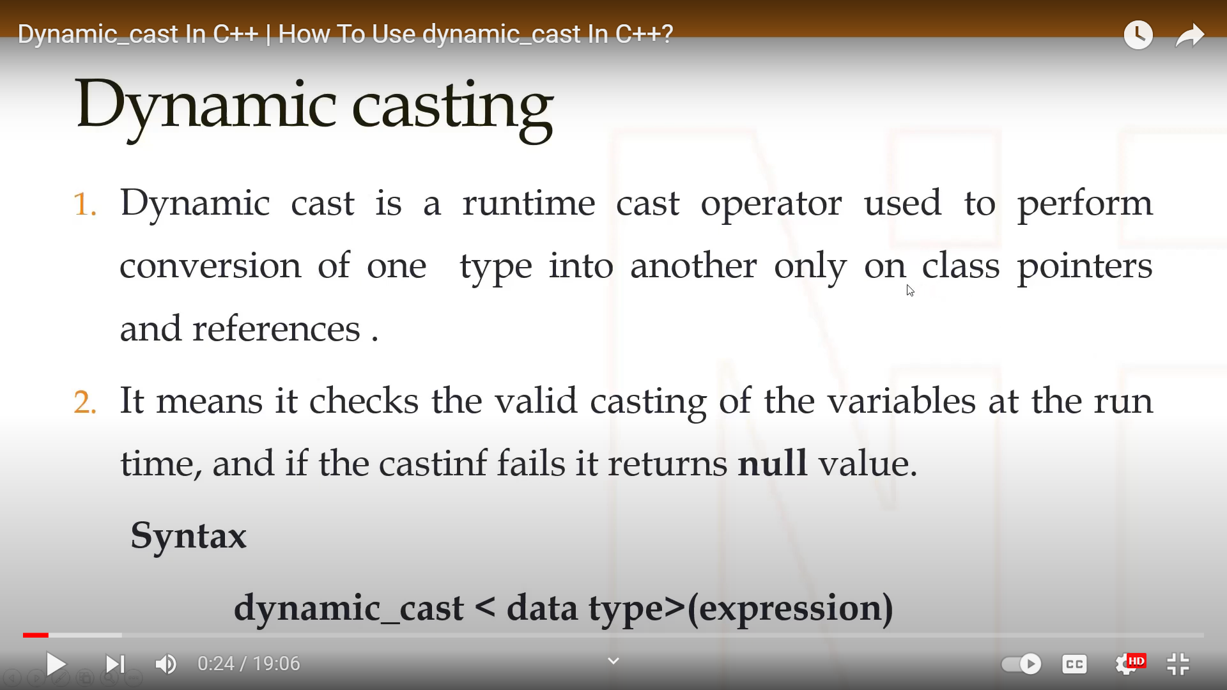

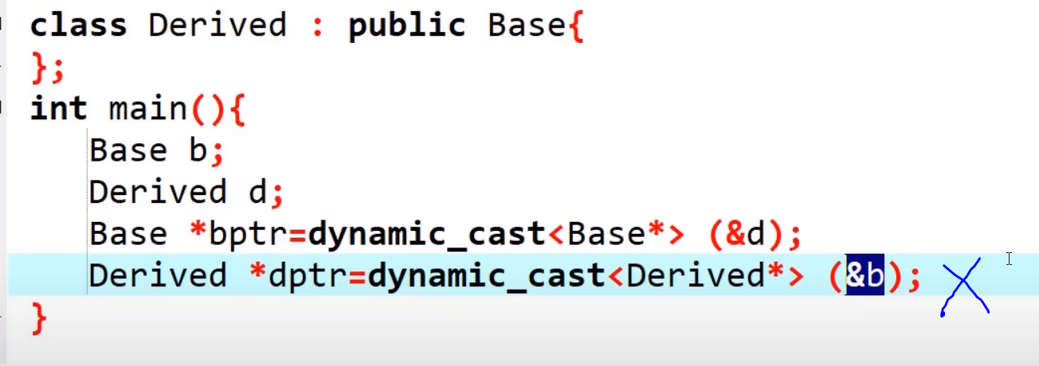

Calling virtual function using dynamic casting :  
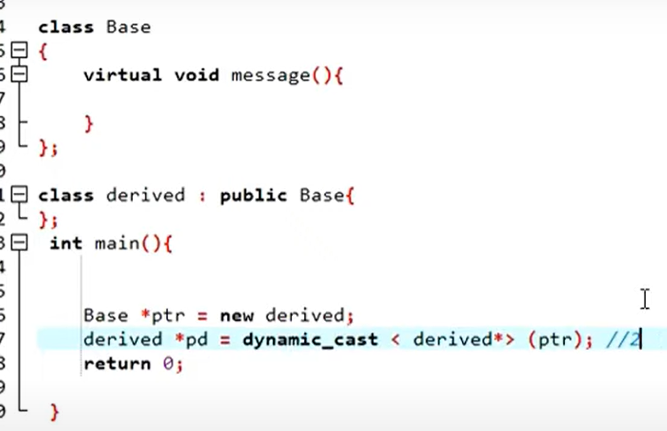

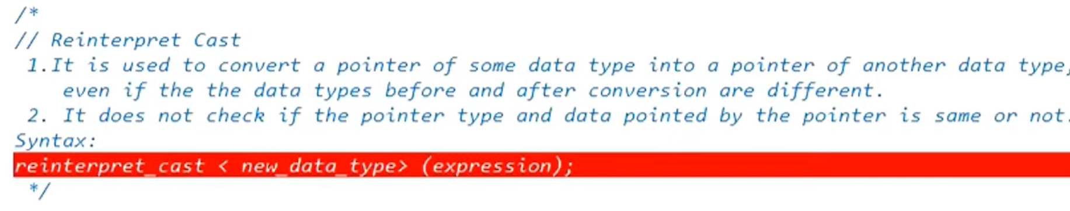

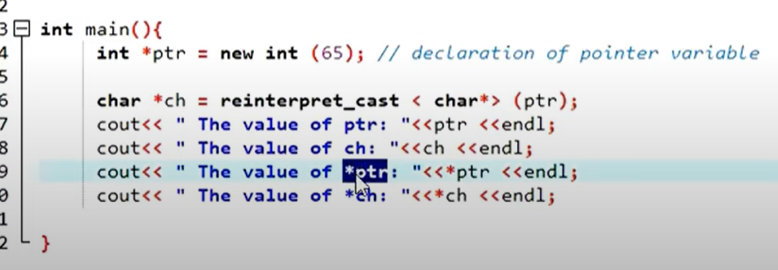

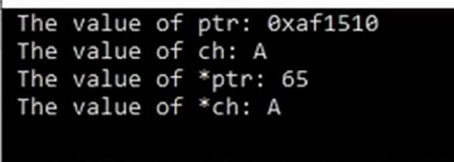

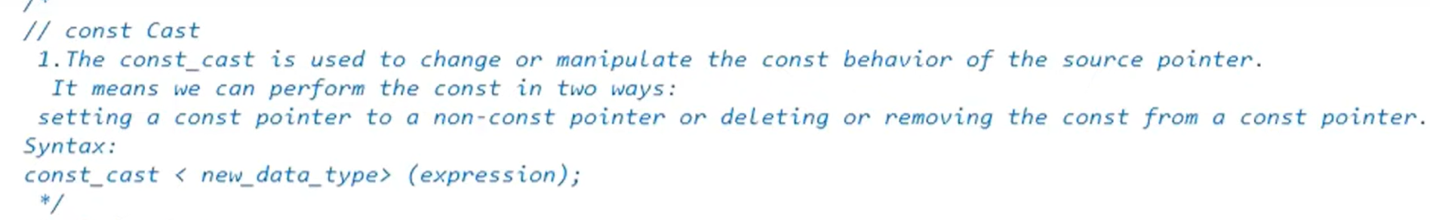

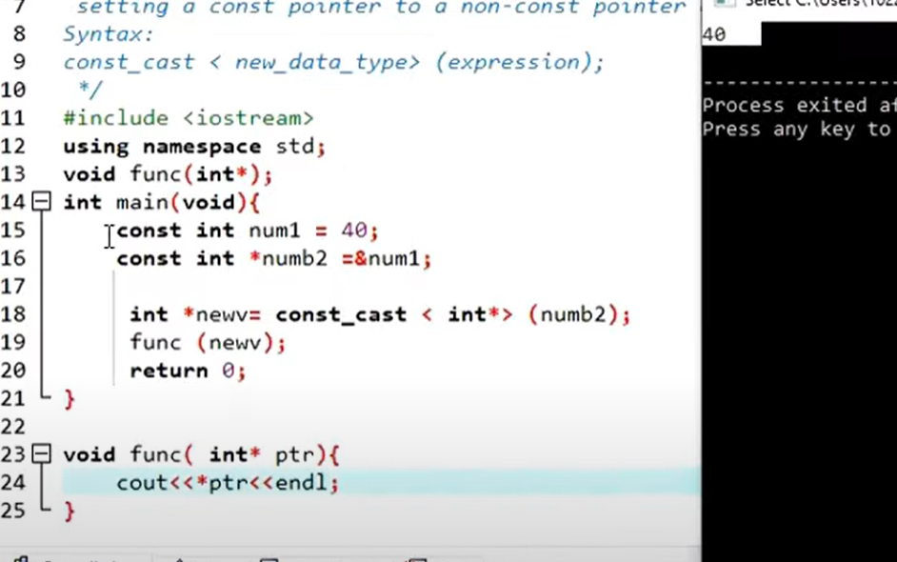

Type punning in C++ by cherno:  
This prints 5,8  
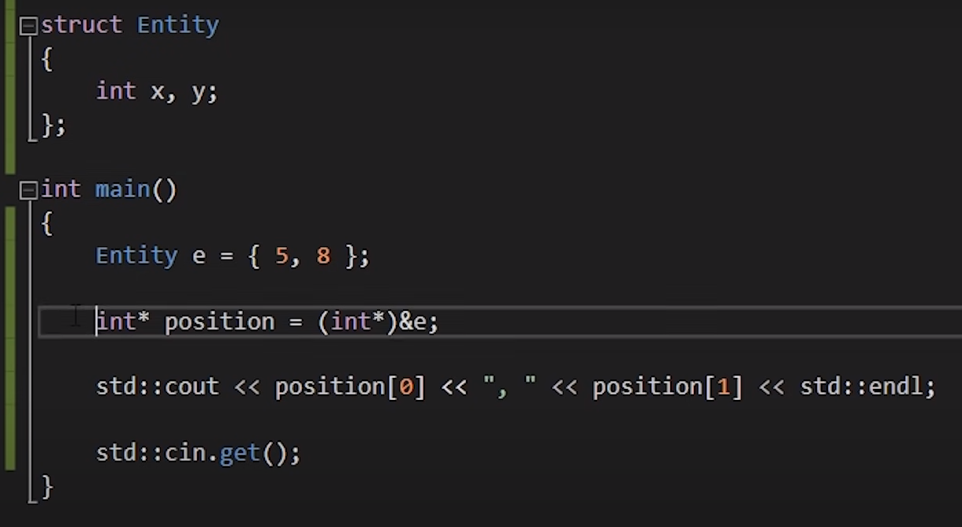

Following prints 8 :  
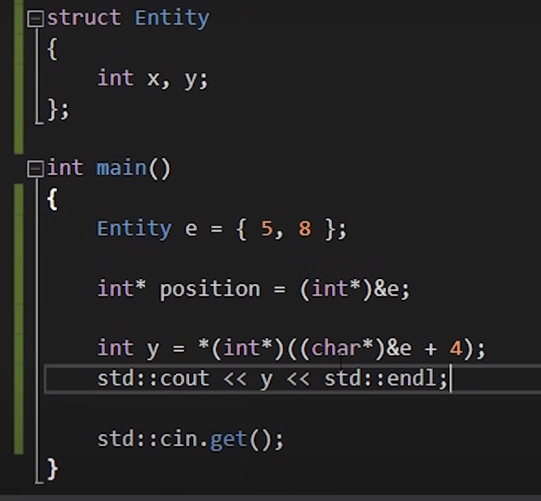

FILE IO operations in C++ :  
[Experimental library header <experimental/filesystem> - cppreference.com](https://en.cppreference.com/w/cpp/header/experimental/filesystem)

Reading and writing to binary files, after running this program , 2 files were created as shown(binary and data) :  
binary was created in 2nd ofstream and data was created by first osftream  
